DNS

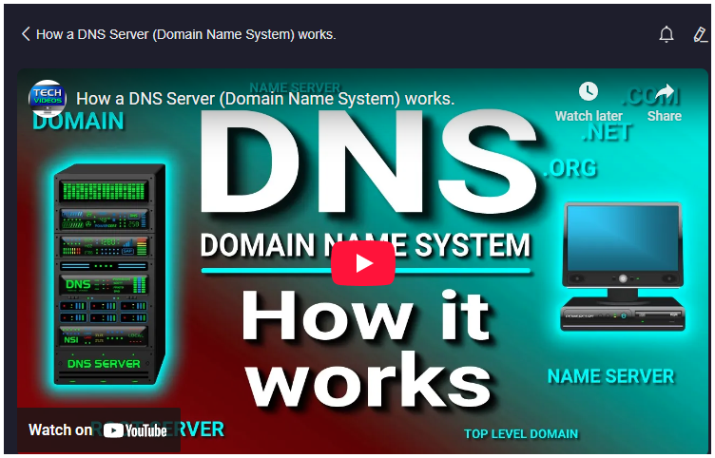
https://youtu.be/mpQZVYPuDGU
### Summary
The video explains the fundamental concept and operation of the Domain Name System (DNS), a crucial part of internet networking that bridges the gap between human-friendly domain names and machine-readable IP addresses. Computers communicate using numeric IP addresses, which are difficult for humans to remember. To solve this, DNS was developed to translate domain names, like yahoo.com, into their corresponding IP addresses. When a user types a domain name into a web browser, the DNS system performs a hierarchical lookup process involving multiple servers: the resolver server (usually provided by the ISP), root servers, Top-Level Domain (TLD) servers, and authoritative name servers. Each server in this chain either provides the requested IP address or directs the query to a more specific server until the authoritative name server returns the IP address. This address is then cached by resolvers to expedite future queries. Overall, DNS acts much like a phone book, converting easy-to-remember names into numeric addresses that computers use to locate websites.

### Highlights
- 🌐 DNS translates human-friendly domain names into computer-friendly IP addresses.
- 🔢 Computers use numeric IP addresses to identify each other on networks, not names.
- 📖 DNS functions like a phone book, resolving domain names to IP addresses.
- 🖥️ The DNS lookup process involves multiple servers: resolver, root, TLD, and authoritative name servers.
- 🗺️ There are 13 sets of root servers worldwide, managed by 12 organizations.
- ⏳ DNS results are cached to speed up future requests for the same domain.
- 🕸️ The hierarchical DNS system ensures efficient and reliable domain name resolution.

### Key Insights
- 🌍 **DNS Bridges Human and Machine Communication:** Humans naturally use names to identify websites, but computers require numeric IP addresses. DNS acts as a translator, enabling seamless interaction between humans and machines. This abstraction simplifies internet usage, preventing users from memorizing complex IP addresses.
- 🏛️ **Hierarchical Structure Ensures Scalability:** The DNS system is designed as a hierarchy with multiple layers—resolver, root servers, TLD servers, and authoritative servers. This layered approach distributes the workload, prevents bottlenecks, and allows the system to scale globally while maintaining efficiency. Each layer narrows down the search for the correct IP address.
- 📡 **Root Servers as the DNS Backbone:** Root servers occupy the highest level in the DNS hierarchy and play a critical role by directing queries to the appropriate TLD servers. Their strategic global placement and management by multiple organizations enhance resilience and availability, ensuring the DNS system remains robust against failures or attacks.
- 🏷️ **Role of TLD Servers in Domain Categorization:** TLD servers specialize in managing top-level domains such as .com, .net, and .org. They act as intermediaries that help route queries from root servers to the authoritative name servers responsible for specific domains. This categorization optimizes query handling and domain management.
- 🕵️ **Authoritative Name Servers Provide Definitive Answers:** The authoritative name servers hold the definitive IP address information for a domain. Being the final authority, they ensure accuracy and consistency in the DNS response. Their role is crucial because the entire DNS resolution process culminates in querying these servers.
- 🔄 **Caching Enhances DNS Performance:** When a resolver receives an IP address for a domain, it caches this information temporarily. Caching reduces the need to repeat the entire lookup process for subsequent requests for the same domain, significantly lowering latency and network traffic. This optimization improves user experience and reduces server load.
- 🔐 **DNS as a Critical Infrastructure Component:** Since DNS underpins almost every online activity—web browsing, email, and many other internet services—its proper functioning is vital for the overall health and security of the internet. Understanding its mechanisms helps highlight the importance of protecting DNS infrastructure from attacks such as spoofing or denial-of-service.
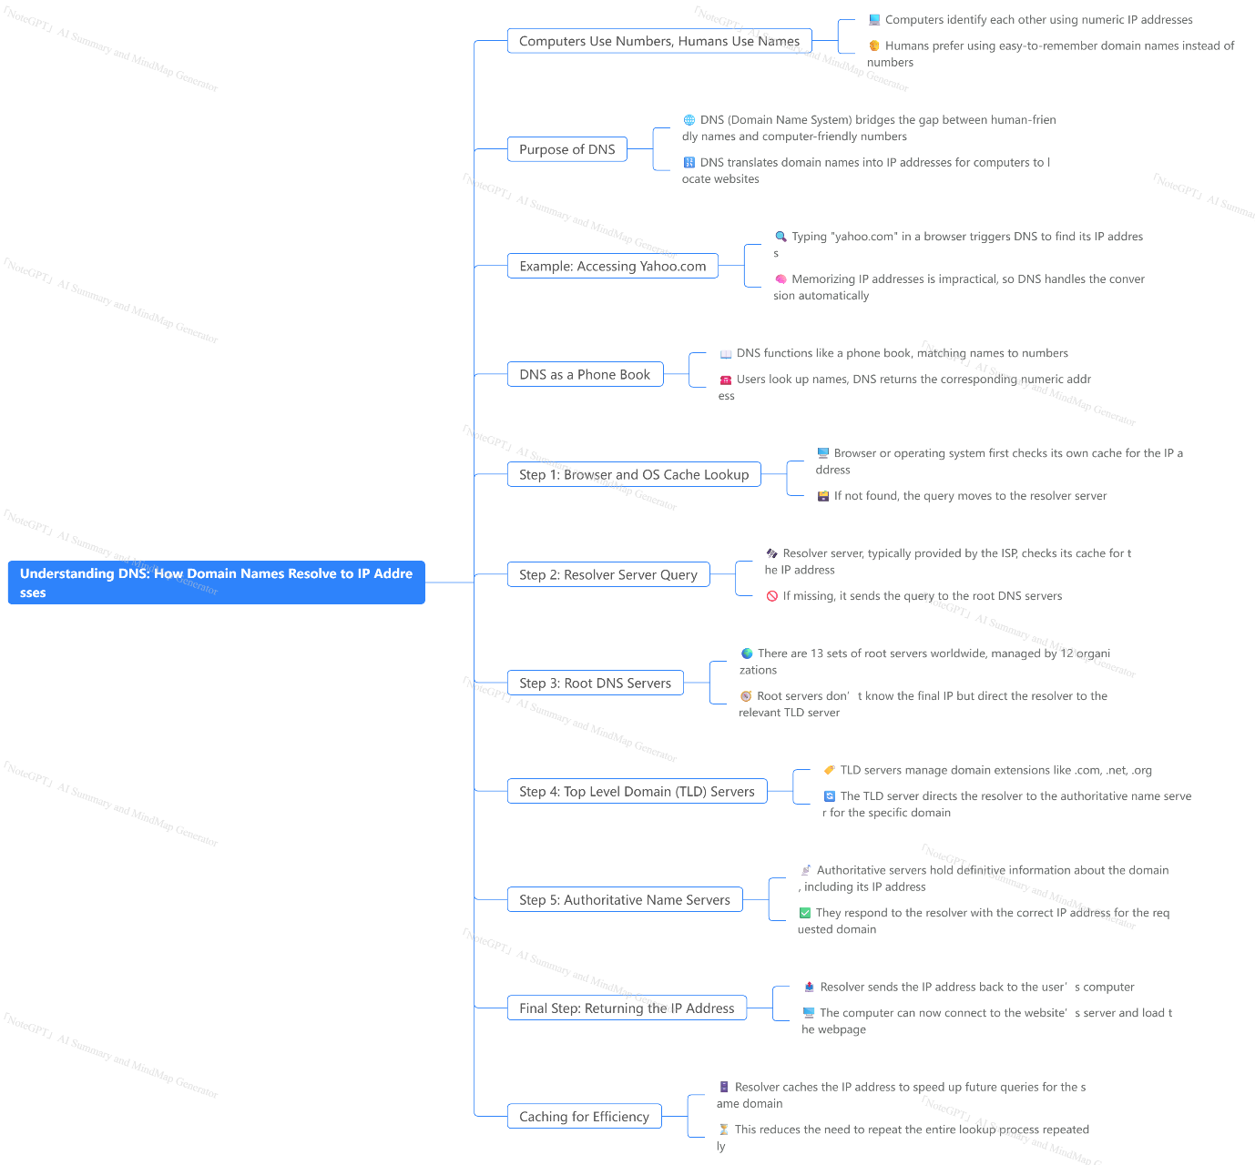

Ports

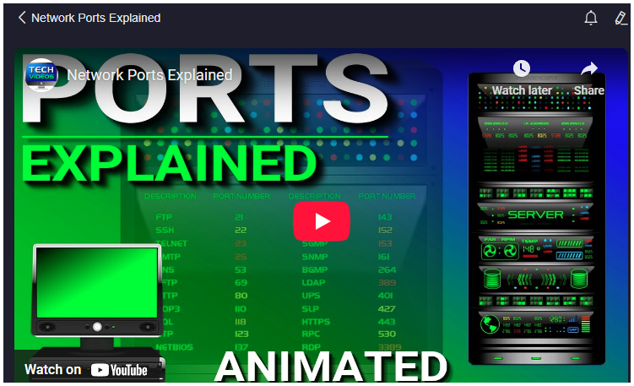
https://youtu.be/g2fT-g9PX9o
### Summary
This video explains the concept of a port in computer networking, emphasizing that a port is a logical, not physical, connection that allows programs and services to exchange information over a network. Ports are identified by unique numbers ranging from 0 to 65535 and are always associated with an IP address, which identifies the specific device on the network. The combination of an IP address and port number enables computers to communicate with specific services on servers, such as web browsing, FTP, or email.

The video uses familiar examples such as port 80 (HTTP for web pages) and port 21 (FTP for file transfers) to illustrate how ports work. When a user enters a domain name like google.com into a browser, the domain is translated into an IP address, and the appropriate port number is appended depending on the service requested. The server then uses the port number to route the request to the correct program or service.

The video also introduces the command-line utility `netstat`, which allows users to view current network connections and the port numbers involved. It explains how dynamic or private ports, typically assigned by the client computer during a session, differ from well-known and registered ports used mainly on servers.

Ports are divided into three categories:
- Well-known ports (0–1023) used for common services like HTTP, FTP, and email.
- Registered ports (1024–49151) assigned by organizations for specific services.
- Dynamic or private ports (49152–65535) used temporarily by client machines.

The video clarifies that although well-known ports are typically server-side, a personal computer can act as a server and use these ports if configured accordingly. It also contrasts port 80 (HTTP) and port 443 (HTTPS), highlighting the latter's role in secure web browsing.

Finally, the presenter recommends further learning through audiobooks available via Audible and promotes a related video on the `netstat` utility.

### Highlights
- 🌐 Ports are logical connections identified by numbers (0–65535) that help programs communicate over a network.
- 🔢 Each port number is tied to an IP address to specify which device and service the communication targets.
- 🌍 Port 80 (HTTP) and port 443 (HTTPS) are the most common ports for web traffic, with HTTPS providing secure connections.
- 📂 FTP uses port 21 to enable file transfers between clients and servers.
- 💻 The `netstat` command-line tool shows active network connections and their port numbers in real time.
- 🛡️ Ports are categorized into well-known, registered, and dynamic/private, with specific roles for servers and clients.
- 🔄 Personal computers can act as servers by listening on well-known ports if configured to do so.

### Key Insights
- 🌐 **Ports as Logical Endpoints for Network Communication:** Ports are essential for enabling multiple services to operate on a single device by logically separating network traffic. This design allows a single IP address to host various applications simultaneously, such as web servers, FTP servers, and email services, by directing incoming requests to the correct program based on the port number.

- 🔢 **IP Address and Port Number Synergy:** The IP address locates the device geographically and within a network, while the port number directs the request to a specific service on that device. This combination is fundamental to the functionality of the internet and local networks, making it possible to have numerous concurrent communications without confusion or data collision.

- 🌍 **Everyday Use of Ports Is Mostly Invisible to Users:** Users typically interact with domain names and services without awareness of the underlying IP addresses or port numbers. However, understanding these concepts is crucial for network troubleshooting, security analysis, and configuring servers or firewalls.

- 📂 **The Role of Standardized Ports and Port Ranges:** The Internet Assigned Numbers Authority (IANA) regulates port assignments to avoid conflicts and ensure interoperability. Well-known ports (0–1023) are reserved for standard services, while registered and dynamic ports provide flexibility for new applications and client-side communications, respectively. This structure maintains order in the vast and complex landscape of internet communications.

- 💻 **`netstat` as a Practical Tool for Network Monitoring:** The video highlights the utility of `netstat` for viewing active connections, including local and remote IP addresses and the ports in use. This tool provides valuable insight into what services your computer is accessing or offering, which is essential for network administrators and security professionals.

- 🛡️ **Security Implications of Ports:** The distinction between port 80 (HTTP) and port 443 (HTTPS) is significant for web security. HTTPS encrypts data, protecting users from eavesdropping and tampering. The increasing adoption of port 443 reflects growing awareness and implementation of secure communication practices on the internet.

- 🔄 **Personal Computers Can Function as Servers:** A personal computer is not limited to client roles; it can host services by listening on well-known ports, such as running a local web server or FTP server. This capability is vital for developers, system administrators, and users who want to share resources or test services locally.

The video provides a clear, practical explanation of ports that balances technical accuracy with accessible examples. It serves as a foundational resource for anyone looking to understand how network communication works at a fundamental level and how ports facilitate the interaction between computers and services on the internet.
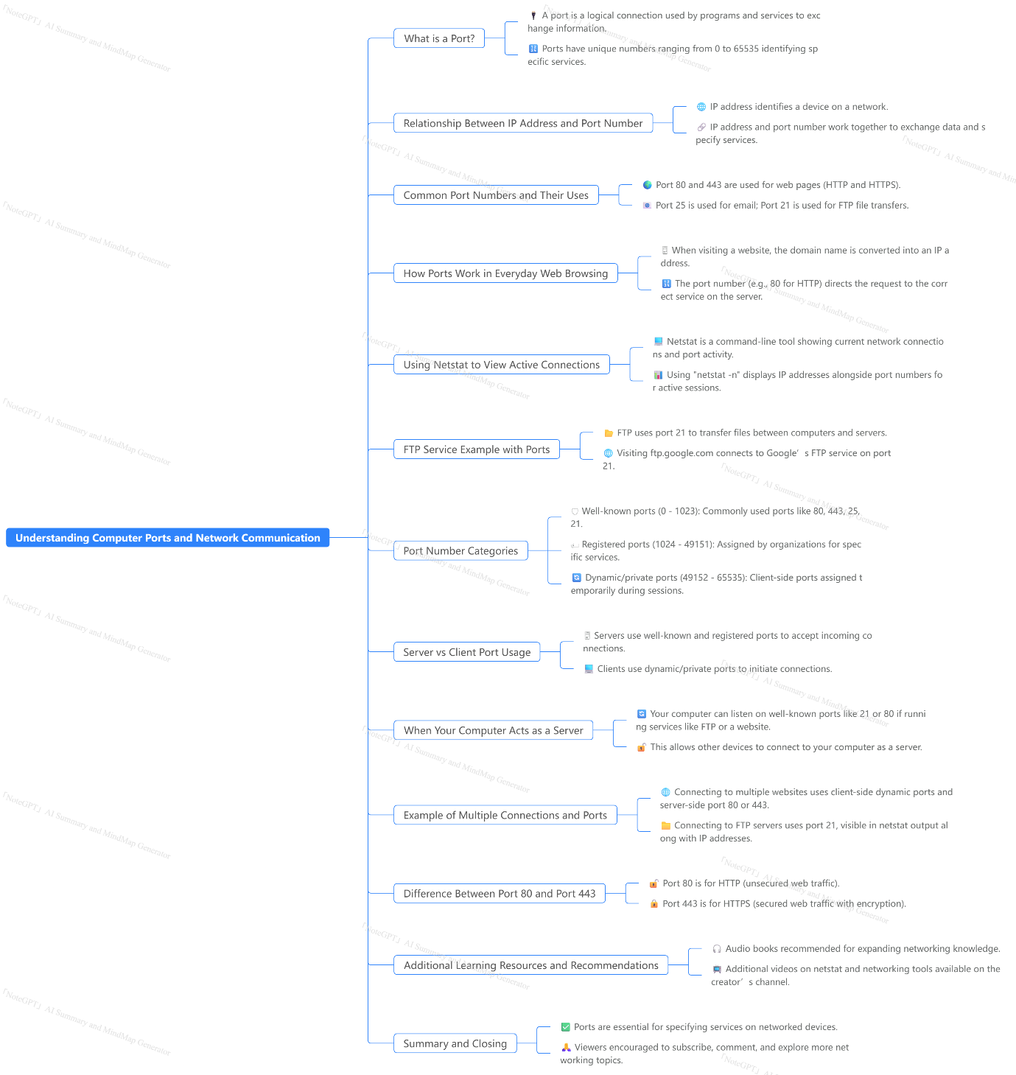

Servers

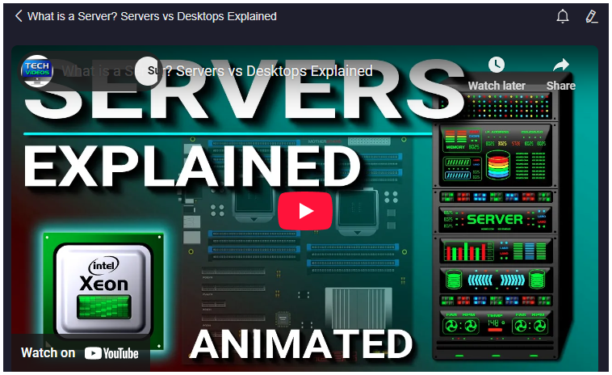
https://youtu.be/UjCDWCeHCzY
### Summary
The video provides a detailed explanation of what a server is, its role, and how it differs from ordinary desktop computers. A server is essentially a dedicated computer that provides specific services to clients over a network, such as retrieving websites, storing data, or managing emails. While larger organizations often use separate servers for each service, smaller organizations might use a single server for multiple services. Importantly, a server is defined by the role it plays rather than its physical form; any computer, including a desktop, can act as a server, although desktops have limitations due to their hardware and software constraints.

Servers require specialized hardware and software to handle continuous operation and large workloads. Unlike desktop processors like Intel Core series, servers use processors such as Intel Xeon, which support multiprocessing, error-correcting code (ECC) memory, higher core counts, and larger cache sizes. ECC memory is crucial for maintaining server reliability by detecting and correcting data errors, preventing system crashes. Servers also use RAID configurations for hard drives to ensure data redundancy and fault tolerance, as well as redundant power supplies to avoid downtime from hardware failure. Additionally, servers run dedicated operating systems like Linux, Windows Server, or macOS Server, which are designed for stability and handling thousands of simultaneous connections.

The video also introduces different types of servers based on the services they provide: web servers host websites; email servers manage the sending and receiving of emails through protocols like IMAP, POP, and SMTP; and database servers store and retrieve data using query languages such as SQL. The video emphasizes the importance of servers in business continuity and overall network infrastructure.

### Highlights
- 🖥️ A server is a dedicated computer that provides services to clients over a network.
- ⚙️ Servers can either handle multiple services on one machine or be dedicated to specific tasks.
- 🔄 Any computer, including a desktop, can act as a server, but desktops have limitations.
- 💻 Server processors like Intel Xeon support multiprocessing and ECC memory, unlike desktop processors.
- 💾 Servers use RAID and redundant power supplies to ensure high availability and data protection.
- 🖥️ Servers run specialized operating systems designed for stability and handling many simultaneous connections.
- 🌐 Different types of servers include web servers, email servers, and database servers, each serving distinct network functions.

### Key Insights
- 🖥️ **Server as a Role, Not Just Hardware:** The video clarifies a common misconception by explaining that a server is not strictly a high-powered physical machine but rather a role that any computer can fulfill by providing services to clients. This understanding broadens the concept of servers and shows that server functionality is defined by software and network configuration as much as hardware. However, the practicality of using a desktop as a server is limited by its hardware and operating system constraints.

- ⚙️ **Dedicated vs. Multi-Service Servers:** Larger organizations typically use dedicated servers for different services to optimize performance and reliability, while smaller organizations might consolidate services on a single server to save costs. This distinction highlights how organizational needs and resources influence server architecture decisions. Dedicated servers reduce the risk of one service affecting another, while multi-service servers increase efficiency but may create single points of failure.

- 💻 **Server-Grade Hardware Enhances Reliability:** Server processors like Intel Xeon are designed to handle heavy workloads with features like multiprocessing support, larger caches, and higher core counts. These attributes enable servers to manage multiple concurrent tasks efficiently, which is essential for enterprise environments requiring high availability and responsiveness. This hardware specialization ensures that servers can perform reliably under constant demand.

- 🛡️ **Error-Correcting Code (ECC) Memory is Crucial:** ECC memory is a critical component in servers because it detects and corrects data corruption in real-time, preventing system crashes and data loss. Desktop processors such as Intel Core do not support ECC, making them less suitable for mission-critical applications. This insight explains why server hardware differs significantly from desktop hardware, emphasizing data integrity and uptime.

- 💾 **RAID and Redundant Power Supplies Ensure Uptime:** The use of RAID configurations allows servers to continue operating even if a hard drive fails, by automatically rebuilding data on replacement drives without downtime. Similarly, redundant power supplies protect servers from power failures by providing backup power sources. These hardware configurations are fundamental for maintaining continuous service and preventing data loss in enterprise environments.

- 🖥️ **Server Operating Systems are Built for Stability and Scalability:** Unlike desktop operating systems, server OSes such as Linux, Windows Server, and macOS Server are optimized to run continuously and handle thousands of simultaneous connections. This robustness is essential in ensuring that servers remain available and responsive under heavy user load, which is critical for businesses and online services.

- 🌐 **Variety of Server Types Reflects Diverse Network Needs:** The video categorizes servers based on the services they provide, such as web servers for hosting websites, email servers for managing email communications, and database servers for storing and retrieving data. Each server type is specialized with its own protocols and software, reflecting the complexity and specialization within network infrastructure. This demonstrates the modular nature of server usage and how different servers collaborate to fulfill organizational IT requirements.

Overall, the video offers a comprehensive overview of servers, emphasizing their roles, hardware and software requirements, and practical use cases within different organizational contexts. It effectively distinguishes servers from desktops and highlights the critical components that ensure server reliability and performance.

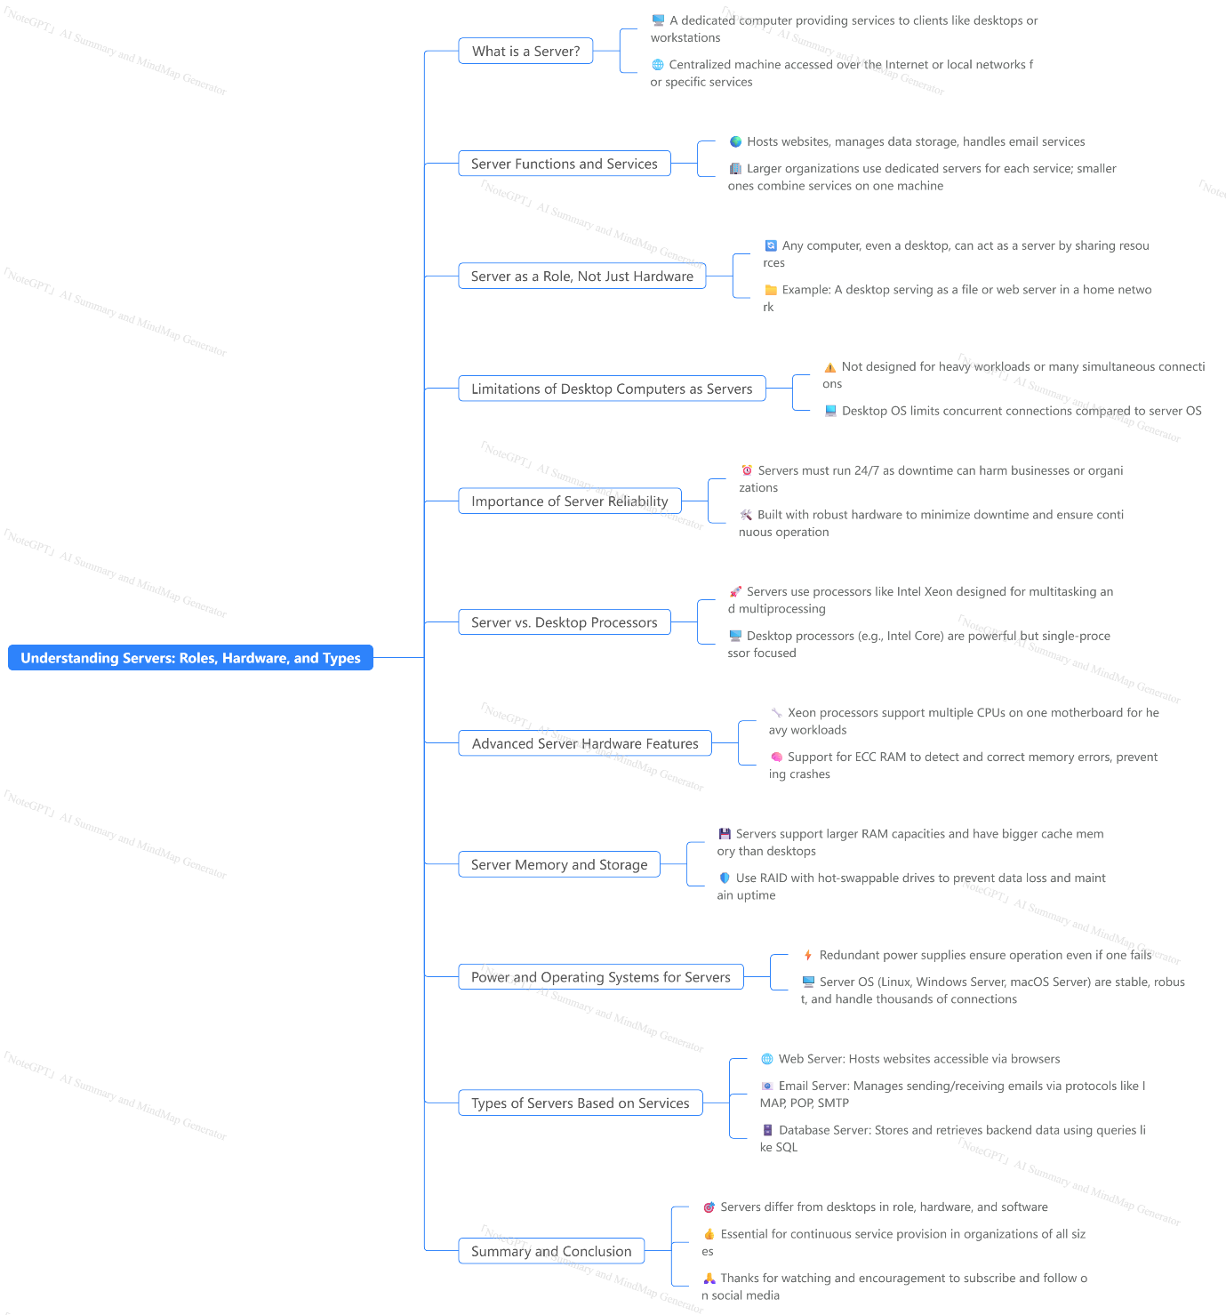

Cloud Computing


https://youtu.be/_a6us8kaq0g

### Summary
This video provides a comprehensive introduction to cloud computing, explaining what it is, how it works, and why it has become an essential technology for individuals and businesses alike. Cloud computing refers to storing and running applications and data on remote servers—known as "the cloud"—rather than on local computers or personal hardware. These servers reside in massive data centers owned by cloud providers like Amazon Web Services (AWS), Microsoft Azure, and Google Cloud Platform, among others. The cloud allows users to access computing resources over the internet, eliminating the need to maintain physical servers.

The video outlines the evolution of computing from traditional setups, such as managing one’s own email server, to using cloud-based services like Gmail or YouTube, which handle storage, processing, and distribution on behalf of users. Key advantages of cloud computing include cost savings, enhanced reliability through data backups and disaster recovery, and scalability that allows businesses to pay only for what they use and easily expand or reduce resources according to demand.

The video also introduces the three primary service models in cloud computing: Infrastructure as a Service (IaaS), Platform as a Service (PaaS), and Software as a Service (SaaS). IaaS provides basic hardware and networking managed by the provider but leaves software management to the user. PaaS takes this further by managing the operating system and runtime environment, allowing users to focus on applications and data. SaaS offers fully hosted applications accessible through a browser, requiring no software installation or infrastructure management by the user; Google Docs is given as a prime example.

The video uses real-world examples like Netflix, which utilizes AWS to manage its vast computing and storage needs, highlighting the benefits of outsourcing IT infrastructure to cloud providers. Ultimately, cloud computing frees individuals and organizations from the complexities and costs of managing their own IT infrastructure, enabling them to focus on their core activities.

### Highlights
- ☁️ Cloud computing means running applications and storing data on remote servers accessed via the internet instead of local machines.
- 🏢 The "cloud" refers to large data centers filled with servers that provide computing services to users worldwide.
- 💸 Major benefits include cost savings, reliability through backups and redundancy, and easy scalability with pay-as-you-go pricing.
- 📧 Traditional setups, like hosting your own email server, are being replaced by cloud-hosted services like Gmail and Hotmail.
- 📺 Platforms like YouTube serve as cloud services for video creators, handling storage and bandwidth needs.
- 🌐 The three cloud service models are IaaS, PaaS, and SaaS, each offering different levels of control and management responsibilities.
- 🔥 Major cloud providers include AWS, Microsoft Azure, and Google Cloud, with AWS holding the largest market share and serving clients like Netflix.

### Key Insights
- ☁️ **Cloud computing shifts the burden of hardware management away from users to specialized providers.** This transition allows users to avoid the high upfront costs, maintenance, and technical challenges of owning and operating physical servers, making technology accessible to smaller businesses and individuals.
- 🏢 **The cloud is essentially a network of interconnected servers housed in massive data centers, enabling vast computational power and storage at scale.** This infrastructure supports diverse services from data storage to running complex applications, offering flexibility not possible with localized systems.
- 💸 **Cost efficiency is a primary driver for cloud adoption, as users pay only for the resources they consume without upfront investments in hardware, software, or facilities.** This model democratizes access to enterprise-grade computing, helping startups and enterprises alike innovate faster without heavy capital expenditure.
- 🔄 **Cloud providers ensure high availability and reliability by maintaining redundant data centers and managing disaster recovery.** This means users experience minimal downtime, and their data is safeguarded against hardware failure or other disruptions, a level of resilience difficult for most companies to achieve on their own.
- 📈 **Scalability in the cloud is dynamic and instantaneous, allowing businesses to adapt quickly to changing demands.** Whether ramping up resources during peak times or scaling down during slower periods, cloud computing provides unmatched flexibility to optimize operational efficiency and cost management.
- 🛠️ **The three service models— IaaS, PaaS, and SaaS—offer varying degrees of control and responsibility, enabling users to choose the best fit for their technical expertise and business needs.** IaaS offers maximum control over software environments, PaaS simplifies development by managing OS and middleware, and SaaS delivers ready-to-use applications with no infrastructure concerns.
- 🎥 **Real-world examples like Netflix illustrate the strategic advantages of cloud computing, allowing companies to focus on their core competencies rather than IT infrastructure management.** Outsourcing to cloud providers reduces operational complexity, speeds up deployment, and leverages cutting-edge technology maintained by experts, which can be a significant competitive edge.

This video serves as an excellent primer for understanding cloud computing fundamentals, its benefits, and the various service models available, providing a solid foundation for anyone interested in leveraging cloud technology.

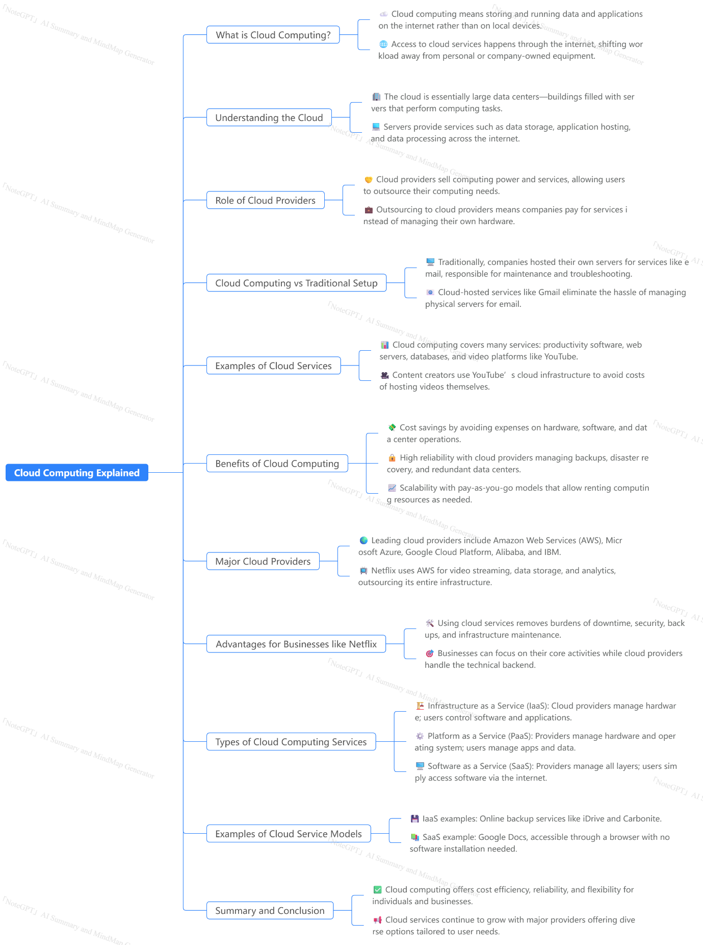

DHCP

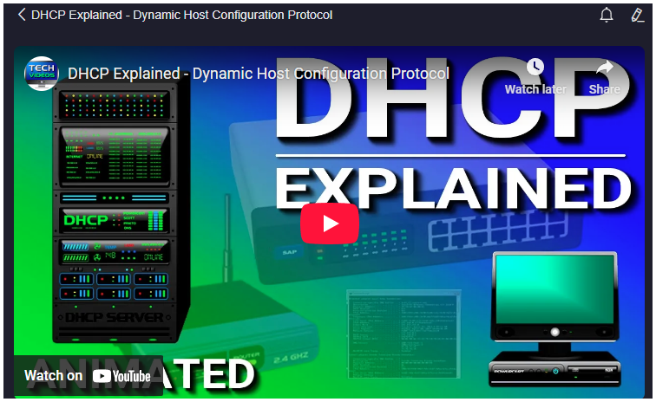
https://youtu.be/e6-TaH5bkjo

### Summary
This video provides a comprehensive overview of DHCP, or Dynamic Host Configuration Protocol, explaining its essential role in network management by automatically assigning IP addresses and other network configuration details to devices. Initially, the speaker contrasts static IP addressing, where network administrators manually assign IP addresses to each device, with dynamic IP addressing, facilitated by DHCP servers. Static IP assignment, while straightforward in small networks, is labor-intensive and prone to errors like IP conflicts, especially in larger environments. Dynamic IP addressing solves these problems by automating the allocation process.

The video explains how DHCP servers assign IP addresses from a defined pool called a scope, which is a customizable range of addresses. Addresses are assigned as leases for a specific period rather than permanently, ensuring efficient management of limited IP resources and avoiding address exhaustion. Leases require computers to periodically renew their IP addresses, and if a device leaves the network without renewing, the IP address lease expires and returns to the pool for reassignment.

The speaker also covers DHCP reservations, which allow certain devices to always receive the same IP address based on their MAC addresses, a useful feature for network printers, servers, and routers that require constant IP addresses. Finally, the video notes that DHCP services can run on dedicated servers or be built into routers, making it accessible for both large enterprise networks and smaller office or home networks.

### Highlights
- 🌐 DHCP automates IP address assignment, simplifying network management.
- 🔧 Static IP addressing requires manual configuration and is inefficient for large networks.
- 📋 DHCP uses scopes, customizable IP address ranges, to allocate addresses dynamically.
- ⏳ IP addresses are assigned as leases, ensuring efficient recycling of addresses.
- 🔄 Devices must renew their IP leases periodically to maintain network connectivity.
- 📌 DHCP reservations allow specific devices to have fixed IP addresses.
- 🖥️ DHCP services can run on servers or routers, suitable for various network sizes.

### Key Insights
- 🌍 **Dynamic IP addressing reduces administrative overhead:** Unlike static IPs, which require manual input of IP addresses, subnet masks, gateways, and DNS servers for each device, DHCP automates these tasks, saving significant time and minimizing human error. This automation is crucial for scaling networks efficiently, especially in business environments with hundreds or thousands of devices.

- ⚠️ **IP conflicts are a major risk in static IP setups:** When administrators manually assign IP addresses, there is a real risk of accidentally duplicating an IP address, causing conflicts that result in network access issues. DHCP eliminates this risk by centrally managing the IP assignment, ensuring uniqueness within the scope.

- 🗺️ **DHCP scopes provide flexible address management:** By configuring scopes, network administrators control the range of IP addresses the DHCP server can assign. This flexibility allows for tailored network designs based on the number of devices and specific subnet requirements, optimizing IP resource allocation.

- ⌛ **Leased IP addresses optimize resource use:** IP addresses are not permanently assigned but leased for a set duration, allowing the DHCP server to reclaim and reassign addresses as devices leave the network. This system is vital for networks with fluctuating device counts, preventing address exhaustion and maximizing available IPs.

- 🔁 **Lease renewal maintains accurate network state:** Devices must periodically communicate with the DHCP server to renew their leases, signaling continued presence on the network. This mechanism ensures the DHCP server only holds active leases for devices still connected, improving network reliability and IP allocation efficiency.

- 🎯 **Reservations serve critical network infrastructure needs:** While most devices use dynamic addressing, certain devices require fixed IPs for consistent communication—such as printers, servers, and routers. DHCP reservations link these devices’ MAC addresses to specific IP addresses, ensuring they consistently receive the same address without manual configuration.

- 🖧 **DHCP service availability in routers enhances accessibility:** The presence of DHCP services in routers, including home and small office routers, democratizes network management by allowing automatic IP configuration even in small-scale networks. This built-in functionality simplifies setup for users without dedicated DHCP servers, supporting plug-and-play network environments.

This video effectively clarifies DHCP’s role in simplifying network configuration, improving scalability, and maintaining network stability, making it an essential protocol for modern IP networking.

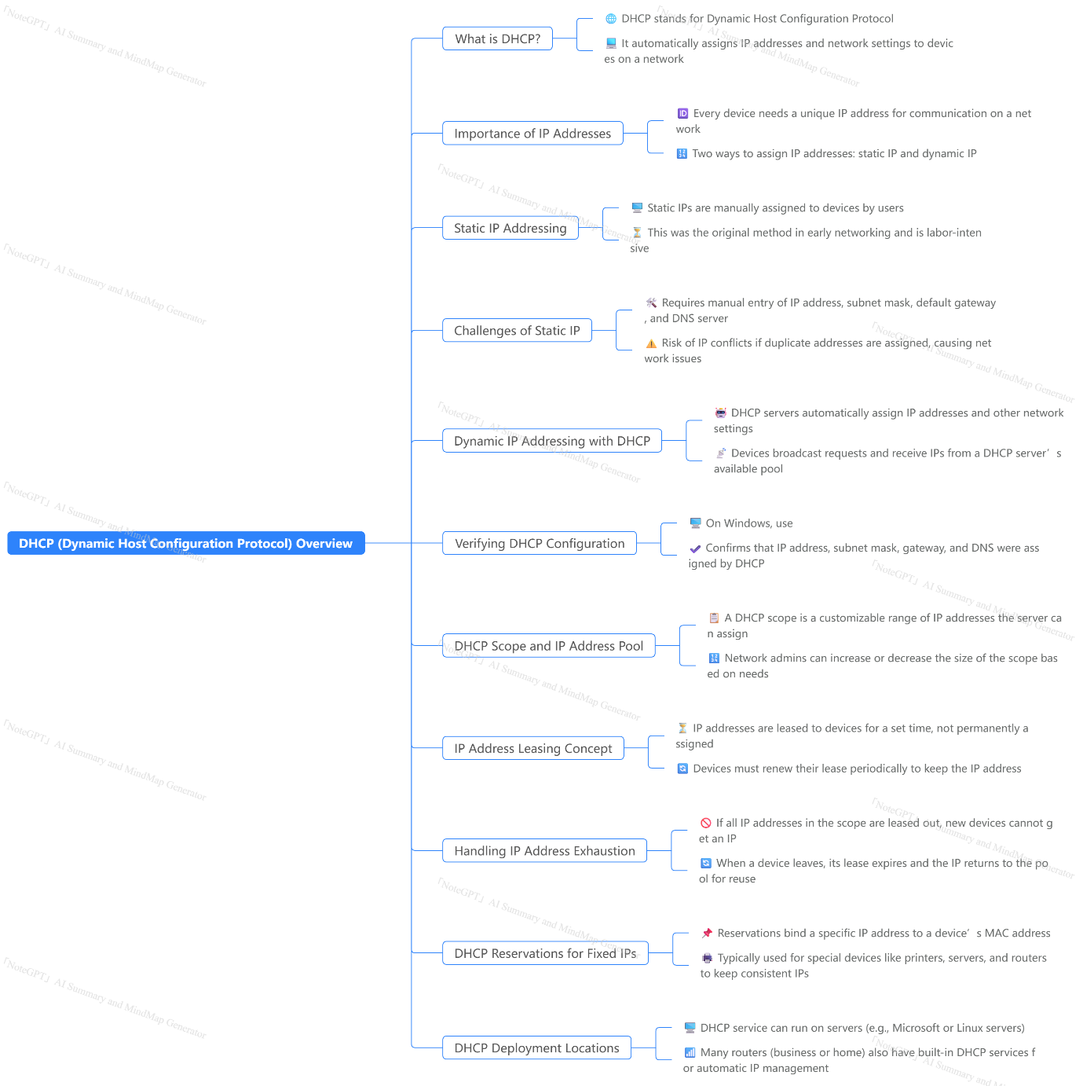

LAYER 2 VS LAYER 3
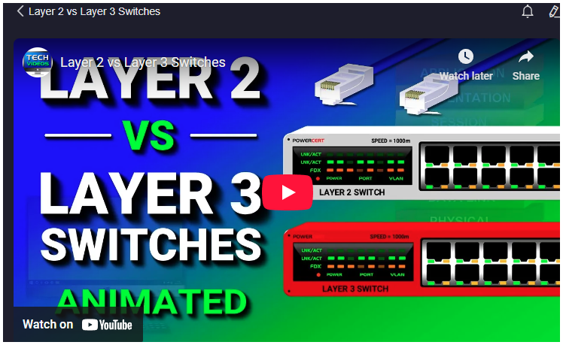
### Summary
This video explains the fundamental differences between layer 2 and layer 3 switches, focusing on their roles within the OSI model and their practical applications in networking environments. It begins by defining what a switch is: a device with multiple ports that facilitates network communication by connecting devices via Ethernet. The concept of layers is then introduced, specifically referencing the OSI (Open Systems Interconnection) model, which breaks down data communication into seven layers.

Layer 2 switches operate at the data link layer (layer 2) and use MAC addresses to forward data between devices on the same local network. These switches learn the MAC addresses of connected devices and build a table to efficiently forward data packets to the correct destination port. Layer 2 switches are common in homes and small to medium-sized businesses due to their simplicity, speed, and cost-effectiveness.

Layer 3 switches, also known as multilayer switches, operate at both the data link layer (layer 2) and the network layer (layer 3). They are capable of routing data using IP addresses, in addition to forwarding based on MAC addresses. This allows layer 3 switches to support inter-VLAN routing, enabling communication between different VLANs (Virtual Local Area Networks) that are segmented into separate IP subnets. The video explains how VLANs can isolate network traffic between departments, such as sales and support, and how a layer 3 switch facilitates communication between these VLANs via switch virtual interfaces (SVIs) acting as default gateways.

The video contrasts layer 3 switches with routers, noting that while routers only operate at layer 3 and have comprehensive routing capabilities, layer 3 switches combine switching and routing functions but may lack some advanced routing features. The summary concludes with a comparative overview: layer 2 switches forward using MAC addresses and are simple and fast, while layer 3 switches provide routing by IP addresses with more complex configuration and cost but enable inter-VLAN communication.

### Highlights
- 🔄 Layer 2 switches operate at the Data Link Layer, forwarding data using MAC addresses.
- 🌐 Layer 3 switches operate at both Data Link and Network Layers, routing data using IP addresses.
- 🖧 Layer 2 switches are common in homes and small to medium businesses due to low cost and speed.
- 🛠 VLANs segment networks into separate broadcast domains to isolate department traffic.
- 🔀 Layer 3 switches enable inter-VLAN routing, allowing communication between different VLANs.
- 🖥 Routers operate exclusively at layer 3 and provide full routing capabilities unlike layer 3 switches.
- 💰 Layer 2 switches are cheaper and faster, while layer 3 switches are more expensive and complex.

### Key Insights
- 🔍 **Importance of the OSI Model in Networking:**
The OSI model provides a standardized framework for understanding network communication by layering functions. Layer 2 and layer 3 switches serve different roles aligned with specific OSI layers, which clarifies their operational differences and use cases. This layering approach helps network engineers design efficient and scalable networks by assigning distinct responsibilities to hardware.

- 🛡 **Layer 2 Switches for Local Traffic Management:**
Layer 2 switches excel in managing local traffic within a single broadcast domain by using MAC addresses to forward frames. This makes them ideal for environments where devices need to communicate within the same subnet, such as home networks or small businesses. Their simplicity requires minimal configuration, contributing to their ubiquity and cost-effectiveness.

- 🌉 **Layer 3 Switches as a Hybrid Solution:**
Layer 3 switches combine switching and routing functionalities, allowing them to forward frames based on MAC addresses and route packets based on IP addresses. This dual capability makes them a versatile solution for more complex networks, such as those involving multiple VLANs or subnets, where inter-VLAN communication is necessary without deploying separate routers.

- 🏢 **VLAN Implementation for Network Segmentation:**
VLANs are crucial for dividing a physical network into multiple logical networks, enhancing security and performance by isolating traffic among different departments or user groups. The use of VLANs reduces broadcast traffic and improves network management. However, because VLANs operate on different IP subnets, communication between them requires routing.

- 🔗 **Inter-VLAN Routing Enabled by Layer 3 Switches:**
Layer 3 switches facilitate inter-VLAN routing by creating Switch Virtual Interfaces (SVIs), which act as default gateways for each VLAN. This eliminates the need for an external router and streamlines traffic management within a network. The layer 3 switch performs routing decisions internally, improving efficiency and reducing latency compared to routing through external devices.

- ⚖ **Trade-offs Between Layer 2 and Layer 3 Switches:**
While layer 2 switches are faster and more affordable, they lack routing capabilities and cannot handle traffic between VLANs or different IP subnets. Layer 3 switches, though more costly and complex to configure, provide routing functionality essential for larger or segmented networks. Choosing between them depends on network size, complexity, and performance requirements.

- 🚦 **Layer 3 Switches vs. Routers – Complementary but Distinct:**
Routers offer comprehensive routing features and operate solely at layer 3, supporting complex routing protocols and WAN connectivity. Layer 3 switches, by contrast, are optimized for high-speed routing within LANs and integrate switching functions. They are not a complete replacement for routers but serve as an efficient solution for intra-network routing, particularly in enterprise environments.

This comprehensive understanding of layer 2 and layer 3 switches equips network professionals with the knowledge to select the right hardware for their specific networking needs, balancing cost, performance, and functionality.
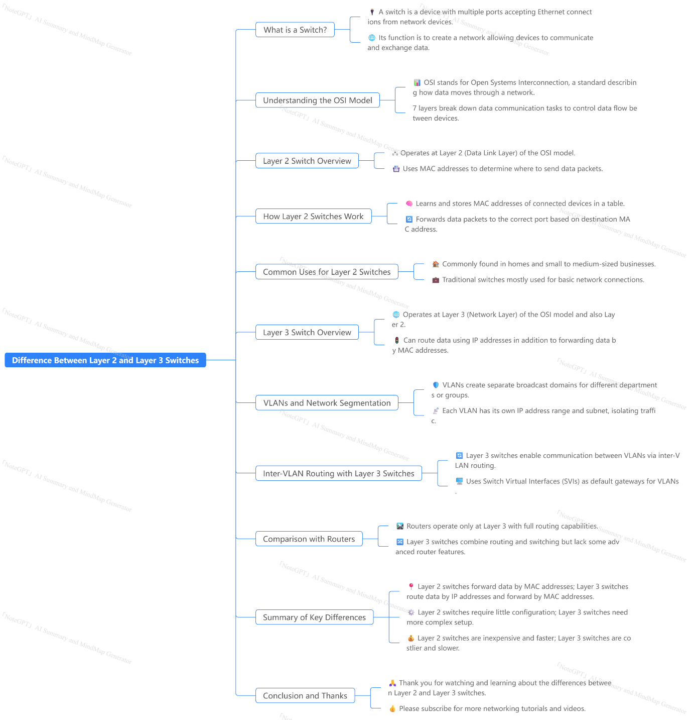

Mac Address

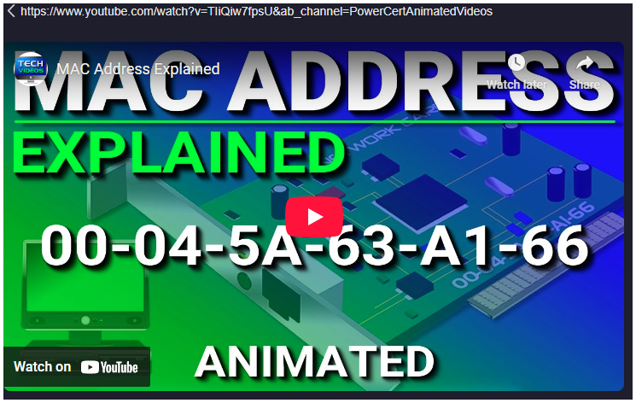

### Summary
This video provides a comprehensive explanation of what a MAC (Media Access Control) address is, its structure, function, and its role in network communication. A MAC address is a unique identifier assigned to every network device, embedded by the manufacturer, and serves as a physical or hardware address. It consists of 6 bytes, with the first 3 bytes representing the manufacturer and the last 3 bytes uniquely identifying the device. MAC addresses are formatted differently across operating systems but serve the same fundamental purpose: enabling devices to communicate on a network.

The video clarifies the distinction between MAC and IP addresses. While IP addresses provide a location or address to reach a device on a network, MAC addresses identify the device itself. IP addresses can change, especially public IPs, whereas MAC addresses remain constant. The video uses an analogy comparing IP addresses to mailing addresses of houses and MAC addresses to the names of the people living inside to illustrate this difference.

In local area networks (LANs), devices use MAC addresses to communicate directly. A device will use the Address Resolution Protocol (ARP) to find the MAC address of another device by broadcasting a request on the local network. For communication across different networks, devices rely on IP addresses to route data via routers, where each router uses ARP to discover the MAC address of the next device in the path until the data reaches its final destination. The MAC address is essential at each step for forwarding data between devices on the same network segment.

The video also demonstrates how to find the MAC address on different systems (Windows, Linux, Mac) and notes that a single device can have multiple MAC addresses corresponding to different network interfaces (e.g., wired, wireless, Bluetooth). Finally, the presenter suggests watching related videos on ARP and default gateways for a deeper understanding of network communication mechanisms.

### Highlights
- 🖥️ MAC address is a unique identifier for network devices, embedded by manufacturers.
- 🔢 MAC addresses consist of 6 bytes: the first 3 identify the manufacturer, the last 3 identify the device.
- 🌐 MAC addresses enable devices to communicate on the same local network using ARP broadcasts.
- 🌍 IP addresses locate devices on a network; MAC addresses identify the devices themselves.
- 🚦 Data transmission across networks uses MAC addresses at each step to forward data correctly.
- 🔍 You can find your device’s MAC address using commands like `ipconfig /all` (Windows) or `ifconfig` (Linux/Mac).
- 🎥 Additional videos on ARP and default gateways provide more detail on network communication.

### Key Insights
- 🔒 **Permanent vs. Dynamic Identifier:** Unlike IP addresses that can change, MAC addresses are permanent, providing a stable identity for devices on networks. This permanence is crucial for low-level network functions like device recognition and local communication. Because MAC addresses are fixed, they serve as a reliable foundation for network protocols that require persistent device identification.

- 🔄 **Two-part Structure of MAC Addresses:** The first half of a MAC address identifies the manufacturer, which helps in device authentication and management. The unique identifier in the last half ensures no two devices from the same manufacturer share a MAC address. This hierarchical structure aids network administrators in tracking and managing devices based on manufacturer information.

- 🌐 **MAC Addresses in Local vs. Wide Area Networks:** MAC addresses primarily operate within local networks. When communicating outside the local network, devices rely on IP addresses to locate the destination, but MAC addresses remain essential for forwarding packets between routers and devices within each network segment. This dual addressing mechanism (MAC for local delivery, IP for global routing) is fundamental to the design of the internet.

- 📡 **Role of ARP in Network Communication:** Address Resolution Protocol (ARP) is a vital mechanism that maps IP addresses to MAC addresses, allowing devices to discover each other’s hardware addresses on the local network. ARP broadcasts are efficient for local device discovery but are limited to local networks, emphasizing the layered approach to network communication. The ARP process also highlights potential security concerns such as ARP spoofing, underscoring the importance of network security measures.

- 🔄 **Routing and Forwarding Using MAC Addresses:** At every hop in a multi-network path, routers use MAC addresses to forward data packets at the data link layer. This stepwise forwarding process ensures data reaches the correct physical device even across complex network topologies, demonstrating the interdependence of MAC and IP addressing in facilitating seamless data transmission.

- 🖥️ **Multiple MAC Addresses per Device:** Devices with multiple network interfaces (wired, wireless, Bluetooth) have distinct MAC addresses for each interface. This setup allows simultaneous connections over different media and gives flexibility in managing network traffic, security policies, and device configurations. It also means that identifying a device may require examining multiple MAC addresses.

- 🔧 **Practical Utility of MAC Address Knowledge:** Understanding how to find MAC addresses and their role in network communication empowers users and administrators to troubleshoot network issues, configure devices correctly, and enhance network security. Knowledge of ARP and default gateways complements this understanding by clarifying how devices interact and route traffic efficiently.

The video provides a clear, practical foundation for anyone interested in networking basics, making complex concepts accessible through analogies and step-by-step explanations.
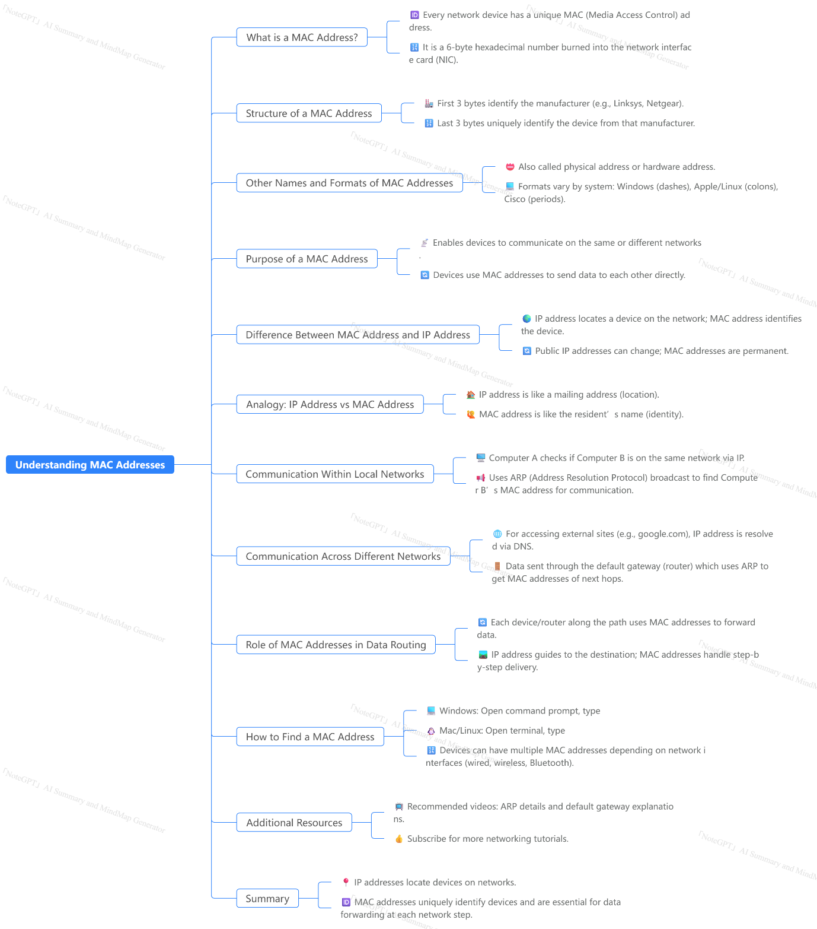
Ping Command
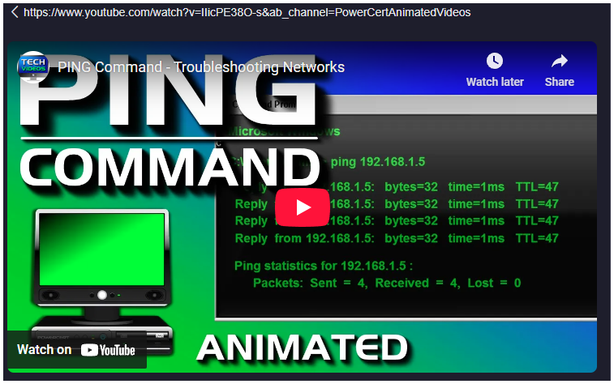
https://www.youtube.com/watch?v=IIicPE38O-s&ab_channel=PowerCertAnimatedVideos

### Summary
The video provides a comprehensive explanation of the **ping command**, a fundamental networking utility widely used for troubleshooting network issues. The presenter begins by introducing the ping command as a simple yet powerful tool to check network connectivity, whether on a local area network (LAN) or over the internet. By sending small data packets (echo requests) to a target IP address or domain name and waiting for replies (echo replies), users can quickly determine if a device such as a computer, server, router, or printer is reachable.

The video delves into practical examples of ping usage, starting with pinging a local server’s IP address. Successful replies indicate proper network connectivity, while no replies or certain error messages suggest potential problems. For instance, a "request timed out" message might indicate the server is down or blocking ping requests via a firewall. The concept of **packet loss**—where fewer than the expected number of packets return—is explored, highlighting causes such as network congestion, faulty hardware, or poor connections. The presenter shares a personal anecdote where packet loss was traced to a faulty modem.

The discussion also covers other common ping errors, like "destination host unreachable," which suggests the absence of a route to the target, possibly due to a down server, disconnected network, or local disconnection. The video then demonstrates how the ping command can be used in real-life troubleshooting scenarios. For example, if a user cannot access websites, pinging a domain like yahoo.com can quickly verify internet connectivity and DNS functionality without immediately checking physical hardware.

Further, the video explains the **loopback test** using the IP address 127.0.0.1 or "localhost" to check if the network interface card (NIC) is functioning correctly. The video also emphasizes the role of ping in diagnosing **DNS issues**, showing how pinging a domain name tests DNS resolution, and how pinging an IP address directly can help isolate DNS problems. Solutions such as flushing the DNS cache or checking DNS settings are briefly mentioned.

Finally, the video notes that ping has various optional switches to customize its behavior, which can be viewed by typing "ping /?" in the command prompt. The video concludes with an encouragement to subscribe for more networking tutorials.

### Highlights
- 🖥️ The ping command tests network connectivity by sending echo requests and waiting for replies.
- 🔄 Successful ping replies confirm that the target device is reachable and network components are working.
- 🚫 "Request timed out" often indicates the target device is offline or blocking ping requests via firewall.
- 📉 Packet loss during ping suggests network congestion, faulty hardware, or bad connections.
- 🌐 Pinging a domain name tests both connectivity and DNS name resolution.
- 🧪 The loopback test (ping 127.0.0.1) verifies whether the local network card is functioning properly.
- ⚙️ Ping supports switches to customize its operation, accessible via "ping /?".

### Key Insights
- 📡 **Ping as a first-step diagnostic tool:** The video demonstrates that ping is often the quickest and simplest initial test to diagnose network problems. It can confirm basic network connectivity before deeper hardware or software issues are investigated, saving significant troubleshooting time.
- 🔍 **Understanding network responses:** Different ping responses provide diagnostic clues—successful replies confirm connectivity, timeouts may indicate firewall or offline devices, and unreachable hosts hint at routing or network disconnection issues. Recognizing these differences helps in effectively pinpointing network faults.
- ⚠️ **Packet loss as an indicator of network health:** Packet loss during ping is a crucial symptom of underlying physical or traffic-related problems. The presenter’s example of identifying a faulty modem through continuous ping tests illustrates how packet loss detection can guide targeted hardware replacement or network optimization.
- 🌍 **DNS resolution testing with ping:** Pinging domain names tests not only connectivity but also DNS functionality, which is critical since DNS translates human-readable domain names into IP addresses. The method of pinging yahoo.com versus directly pinging an IP address like 8.8.8.8 (Google’s DNS) is an effective way to isolate DNS issues from general network connectivity problems.
- 🔄 **Loopback testing for NIC validation:** The loopback test with 127.0.0.1 is an essential validation step for the network interface card. This test checks the NIC’s internal functionality without sending data over the network, helping to distinguish between local hardware failures and external network issues.
- 🛠️ **Streamlining troubleshooting by logical order:** The video stresses the importance of a systematic approach—starting with ping tests before physically checking cables or hardware. This logical troubleshooting sequence is more efficient and reduces unnecessary steps, especially for common connectivity failures.
- ⚙️ **Customizing ping with switches:** The mention of ping switches highlights the command’s flexibility. Advanced users can adjust ping parameters such as packet size, timeout duration, or continuous pinging, enabling more tailored diagnostics depending on specific network environments or issues.

This comprehensive overview of the ping utility equips viewers with foundational knowledge and practical troubleshooting strategies, emphasizing how a simple command can yield deep insights into network health and connectivity.

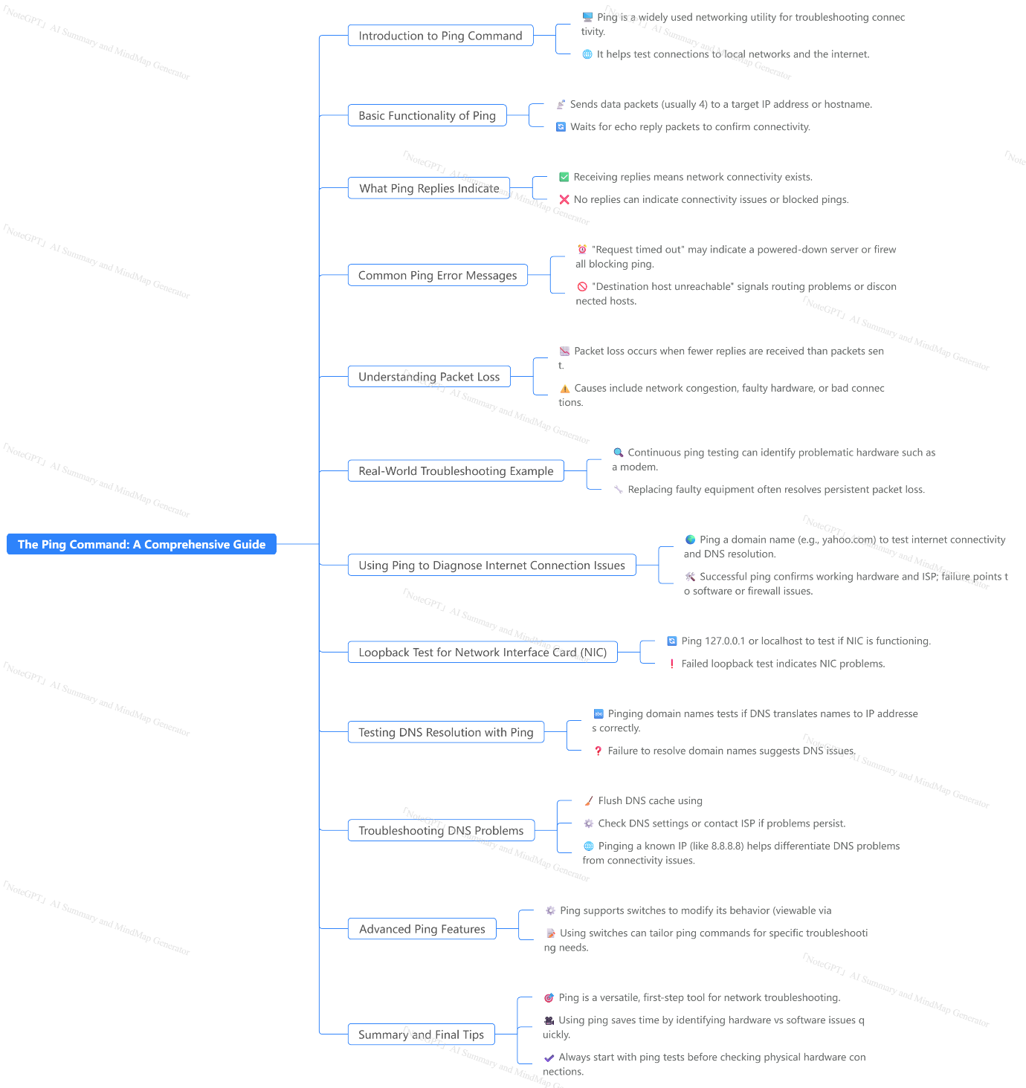

Firewall

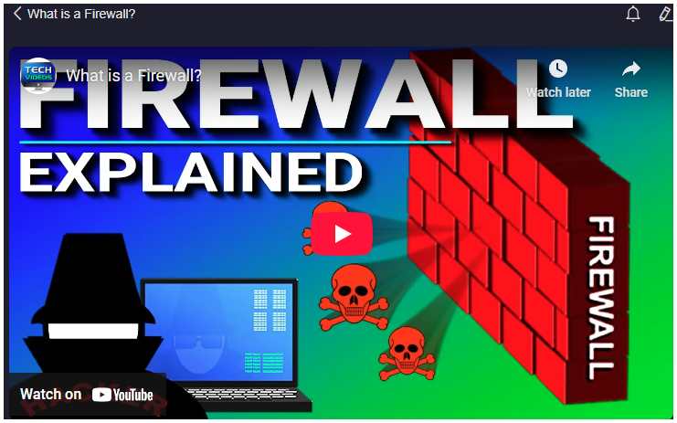
### Summary
A firewall is a critical security system designed to protect private networks from unauthorized access and harmful traffic originating from the public internet. Functioning as a barrier, it filters incoming and outgoing data based on predefined security rules, known as access control lists, which are customizable by network administrators. These rules can be based on various criteria such as IP addresses, domain names, protocols, ports, and even keywords. The primary role of a firewall is to block malicious traffic while allowing legitimate communication, thereby safeguarding networks from hackers and cyber threats. The concept of a firewall draws its analogy from physical firewalls in buildings that prevent the spread of fire, similarly preventing harmful digital intrusions from spreading within a network.

There are two main types of firewalls: host-based and network-based. Host-based firewalls are software installed on individual computers to protect only that device. Examples include built-in firewalls in recent Microsoft operating systems and third-party software like Zone Alarm. Network-based firewalls, on the other hand, are hardware-software combinations that protect the entire network by managing traffic at the network layer. Network firewalls can be standalone devices, integrated into routers, or deployed via cloud services, commonly used by larger organizations. Many organizations implement both types to achieve layered security—network firewalls act as the first line of defense, while host-based firewalls provide additional protection for individual systems. This layered approach ensures maximum security by mitigating the risk if one firewall layer is bypassed.

### Highlights
- 🔥 Firewalls act as a protective barrier between private networks and the public internet, blocking unauthorized and harmful traffic.
- 🛡️ Firewalls filter network data using customizable access control lists, defining what traffic is allowed or denied.
- 🏢 The term "firewall" originates from building fire barriers that prevent the spread of fire, analogous to network firewalls preventing cyber threats.
- 💻 Host-based firewalls protect individual computers and are typically software installed on the device.
- 🌐 Network-based firewalls protect entire networks and can be hardware, software, or cloud-based solutions.
- 🔄 Many organizations use both host-based and network-based firewalls to ensure layered security protection.
- 📡 Firewall rules can control access based on IP addresses, ports, protocols, domain names, programs, and keywords.

### Key Insights
- 🔥 **Firewall as a Crucial Security Layer:** The firewall is foundational in cybersecurity, acting as the first line of defense against external threats. Its ability to filter traffic ensures that malicious actors cannot easily penetrate private networks, highlighting its indispensable role in both home and enterprise environments. Without a firewall, networks are vulnerable to attacks that could compromise sensitive data and disrupt operations.
- 🛠️ **Customizable Access Control Enhances Security Flexibility:** Firewalls operate based on rules set by administrators, allowing granular control over incoming and outgoing traffic. This customization means organizations can tailor firewall policies to their unique security needs, balancing openness and protection. For example, allowing only certain IP addresses or blocking specific port numbers reduces attack surfaces. This flexibility is crucial in adapting to evolving network architectures and threat landscapes.
- 🏢 **Analogous to Physical Firewalls for Clear Conceptual Understanding:** Using the analogy of a physical firewall in buildings helps users and administrators understand the abstract concept of network security. Just as a building firewall contains fire to prevent total destruction, a network firewall contains malicious traffic, preventing widespread damage to digital infrastructure. This analogy is effective for educational purposes and emphasizes the firewall’s protective function.
- 💻 **Host-Based Firewalls Provide Endpoint-Level Security:** These firewalls protect individual devices, which is especially important in environments where devices connect to multiple networks or where network-based firewalls cannot be fully relied upon. As endpoints are common targets for cyberattacks, host-based firewalls provide an essential security layer that complements network defenses, reducing the risk of malware spreading within an organization.
- 🌐 **Network-Based Firewalls Secure Entire Networks:** By filtering traffic at the network perimeter, these firewalls prevent threats from even reaching internal devices. Their deployment as standalone appliances, integrated router features, or cloud services offers versatility to organizations of varying sizes. For large enterprises, standalone network firewalls offer robust, centralized control, while smaller organizations benefit from integrated solutions that are cost-effective and easier to manage.
- 🔄 **Layered Firewall Deployment Maximizes Security:** Combining host-based and network-based firewalls creates multiple defense layers, ensuring that if a threat bypasses one layer, the other can still stop it. This defense-in-depth strategy is a best practice in cybersecurity, enhancing resilience against sophisticated attacks that might slip through a single security measure. It also distributes security responsibilities across the network and endpoint levels.
- 📡 **Multi-Faceted Rule Criteria Enhance Threat Filtering:** Firewalls do not rely solely on IP addresses to filter traffic; they can also use domain names, protocols, ports, and program-level data. This multi-dimensional filtering capability allows firewalls to more precisely identify and block threats, such as blocking traffic on vulnerable ports or restricting access to certain applications. This granular control helps prevent exploitation of network services and reduces the risk of breaches from multiple angles.

The video effectively explains the fundamental concepts of firewalls in a clear and structured manner, making it accessible to both technical and non-technical audiences while emphasizing the critical role firewalls play in modern network security.

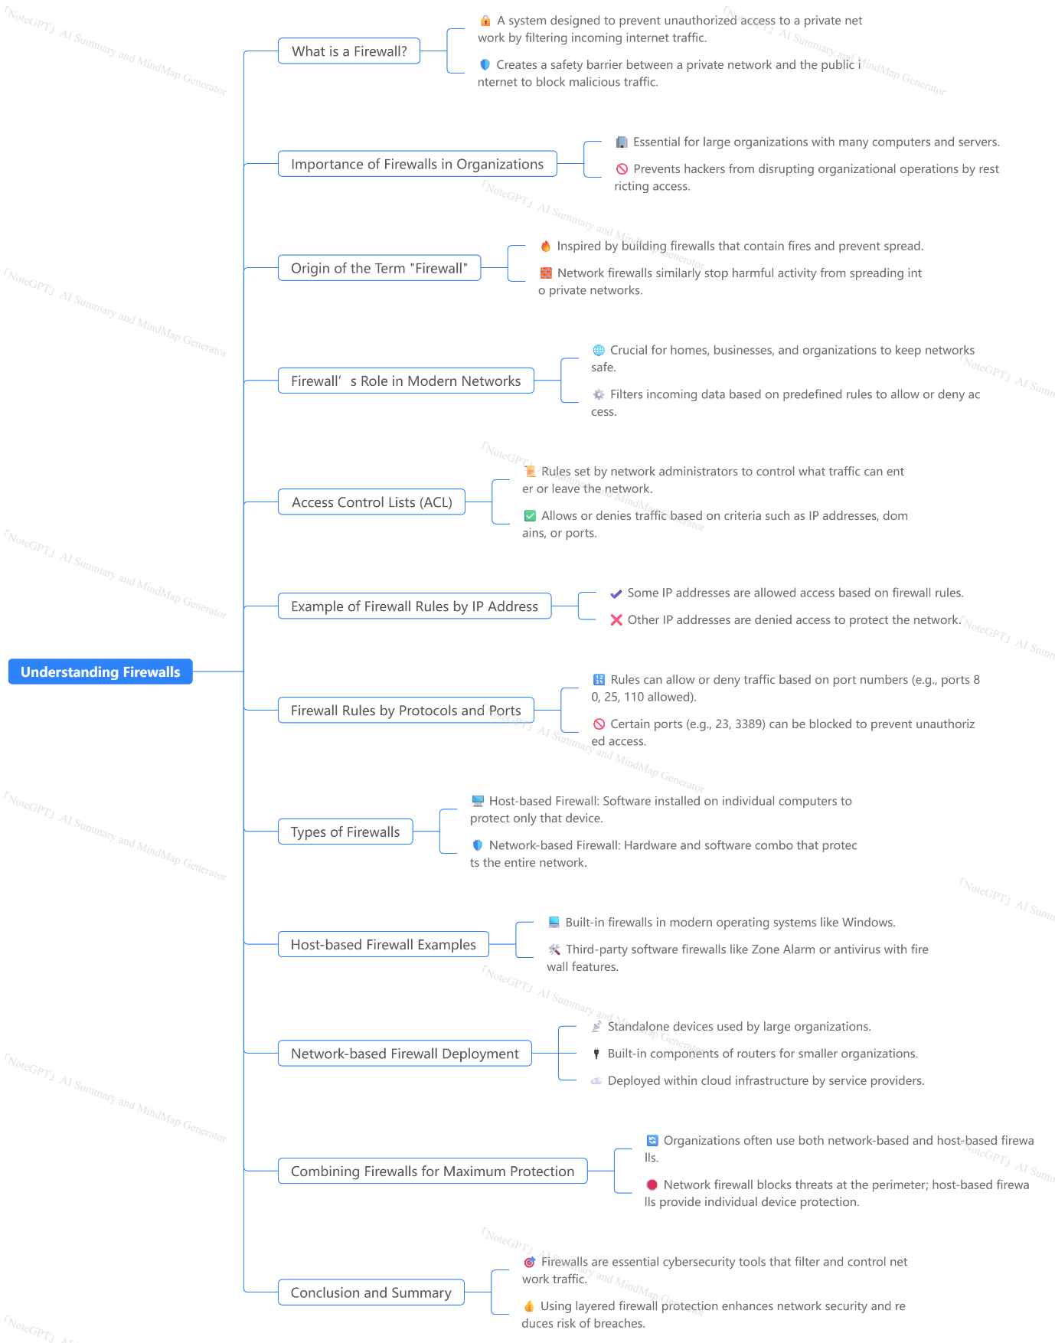

Subnet Mask
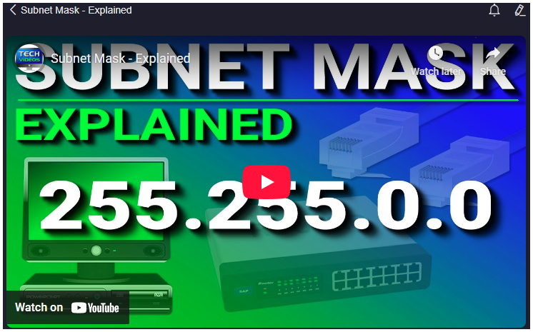
https://www.youtube.com/watch?v=s_Ntt6eTn94&ab_channel=PowerCertAnimatedVideos
### Summary
The video provides a detailed explanation of subnet masks, an essential concept in computer networking, especially related to IPv4 addressing. It begins by defining an IP address, specifically IPv4, as a 32-bit number divided into four octets, each ranging from 0 to 255. Each IP address has two fundamental parts: the network portion and the host portion. The subnet mask is introduced as a key tool used to distinguish these two parts by masking the network portion in binary format.

The video emphasizes that computers operate using binary numbers rather than decimal, explaining how to convert IP addresses and subnet masks from decimal to binary. Using an 8-bit octet chart, the presenter demonstrates how to translate decimal numbers to binary by marking bits as 1 or 0, depending on whether they contribute to the total value. This binary understanding is crucial for determining which part of an IP address is the network and which part is the host.

Several examples illustrate how default subnet masks (such as 255.255.255.0, 255.255.0.0, and 255.0.0.0) map to network and host portions. The video then introduces more complex subnet masks, such as 255.255.224.0, showing how non-standard subnet masks can carve out different sizes of sub-networks.

The video explains why IP addresses must have network and host parts: it enables subnetting, which breaks a large network into smaller, manageable subnetworks. This segmentation is vital to avoid excessive broadcast traffic that can slow or crash networks. Routers play a key role by separating these subnetworks and preventing broadcasts from spilling over.

An example is provided of subnetting a small business network with 12 computers divided into 3 departments. The presenter explains how subnetting is achieved by "borrowing bits" from the host portion of the subnet mask to create multiple smaller networks. The video walks through borrowing 1 to 6 bits, showing the exponential increase in the number of subnets and the corresponding decrease in hosts per subnet.

The video briefly touches on IP address classes (A, B, and C), explaining their default subnet masks and the typical organizational sizes that use each class. It introduces CIDR (Classless Inter-Domain Routing) or slash notation as a shorthand to represent subnet masks by counting the number of bits set to 1.

Finally, the video encourages beginners to explore further learning resources and provides an offer for a free audiobook on networking.

### Highlights
- 🖥️ IPv4 addresses are 32-bit numbers divided into four octets ranging from 0-255.
- 🔢 Subnet masks help identify the network and host portions of an IP address by using binary masking.
- 💡 Computers communicate using binary, requiring conversion from decimal IP addresses and subnet masks.
- 🛠️ Subnetting breaks large networks into smaller subnets to reduce broadcast traffic and improve manageability.
- 🔄 Borrowing bits from the host portion in a subnet mask creates multiple subnets with fewer hosts each.
- 📊 IP address classes (A, B, C) determine default subnet masks and the number of hosts a network can support.
- ✂️ CIDR notation (/24, /25, etc.) is a compact way to represent subnet masks by counting the number of network bits.

### Key Insights
- 🧮 **Binary Representation is Fundamental to Networking:** Although IP addresses and subnet masks are shown in decimal for human readability, computers operate exclusively in binary. Understanding how to convert between decimal and binary is essential to grasping how subnet masks function and how networks are structured. This binary perspective reveals how network and host bits are determined, which is critical for subnetting and network design.

- 🔍 **Subnet Masks Define Network Boundaries:** The subnet mask acts as a filter, where each bit set to 1 denotes the network portion of the IP address, and each bit set to 0 denotes the host portion. This distinction allows devices and routers to identify which part of an IP address corresponds to the network and which corresponds to individual hosts, enabling precise routing and communication within and between networks.

- 🌐 **Subnetting Improves Network Efficiency and Security:** Without subnetting, large networks become overwhelmed with broadcast traffic, as every device receives broadcast messages intended for specific targets. By dividing a large network into smaller subnets, broadcast traffic is confined to smaller groups, reducing congestion and improving overall network performance. Subnetting also enhances security by isolating different departments or groups within an organization, preventing unnecessary exposure to all network traffic.

- 📉 **Trade-off Between Number of Subnets and Hosts:** Borrowing bits from the host portion of the subnet mask exponentially increases the number of available subnets but simultaneously reduces the number of hosts per subnet. This trade-off requires network designers to carefully balance between the number of needed subnets and the number of devices each subnet must support, ensuring efficient allocation of IP addresses without wastage.

- 🏢 **IP Address Classes Cater to Different Organizational Sizes:** Class A, B, and C IP addresses provide default subnet masks suited to organizations of varying sizes. Class A supports millions of hosts, ideal for large ISPs; Class B supports tens of thousands, suitable for medium to large companies; and Class C supports up to 254 hosts, perfect for small businesses or home networks. Recognizing the appropriate class helps organizations procure IP address ranges that fit their needs without excessive or insufficient address space.

- ✂️ **CIDR Notation Simplifies Subnet Mask Representation:** Classless Inter-Domain Routing (CIDR) notation provides a concise way to denote subnet masks by indicating the count of bits set to 1, such as /24 or /26. This notation is widely used in modern networking because it simplifies writing, reading, and configuring subnet masks, especially when dealing with non-default subnetting schemes beyond traditional classful boundaries.

- 🚦 **Routers Control Traffic Between Subnets:** Subnets are physically or logically separated by routers, which prevent broadcast traffic from crossing subnet boundaries. This containment drastically reduces unnecessary network traffic, prevents broadcast storms, and allows routers to intelligently route data between subnets. This design is fundamental to scalable and efficient network infrastructure.

This video offers a foundational understanding of subnet masks and their role in networking, serving as a stepping stone toward more advanced subnetting concepts and network design strategies.
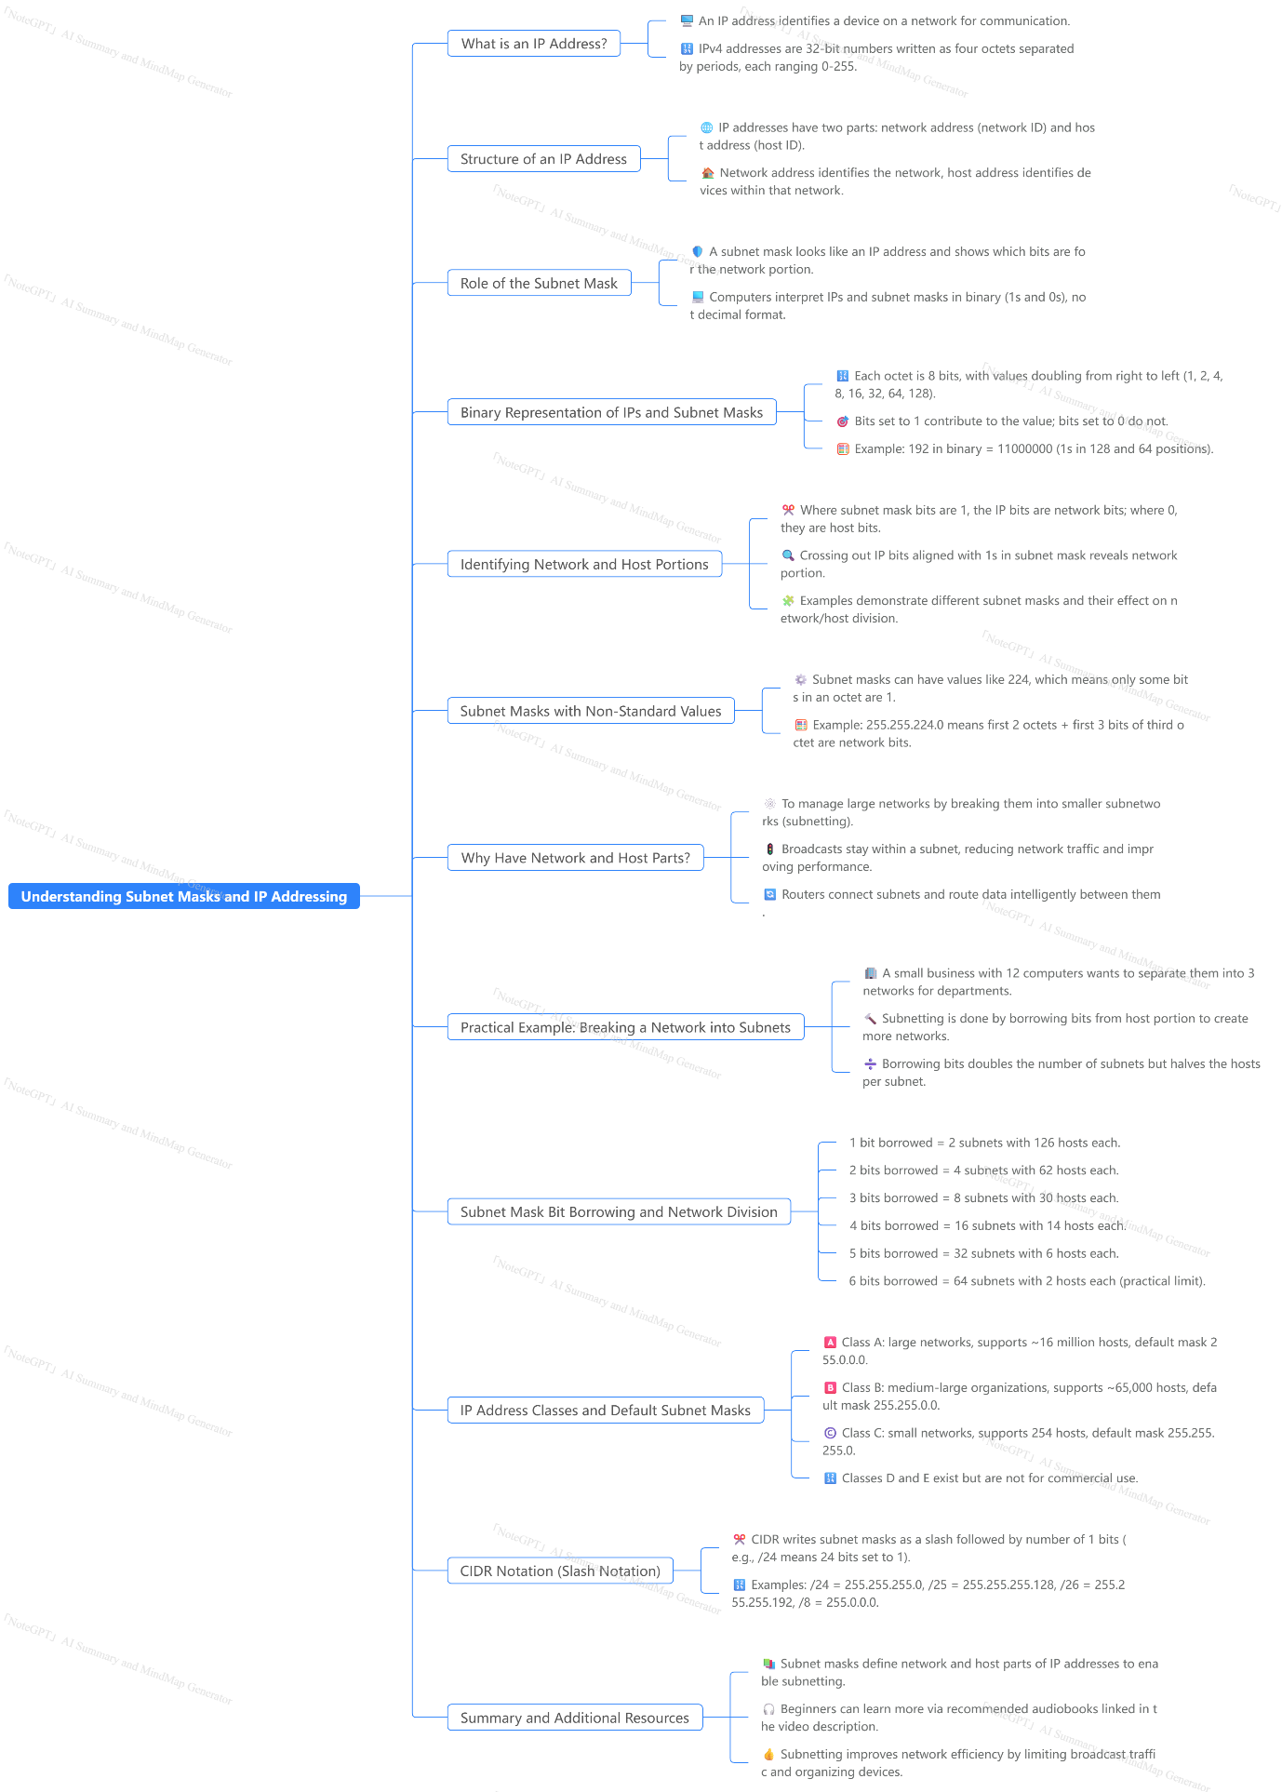

NAT
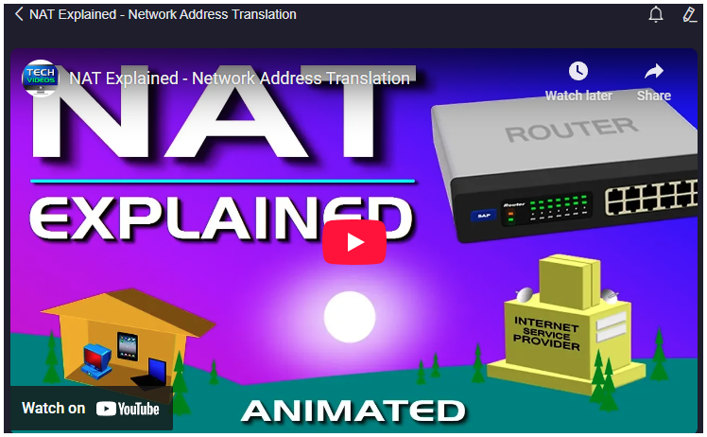
https://www.youtube.com/watch?v=FTUV0t6JaDA&ab_channel=PowerCertAnimatedVideos

### Summary
Network Address Translation (NAT) is a crucial service used in routers to manage the limited availability of IPv4 public IP addresses by translating sets of IP addresses from one form to another. The original IPv4 addressing scheme, which provides about 4 billion addresses, was insufficient to accommodate the rapid growth of the internet. To address this limitation, engineers developed private IP addresses and NAT. Public IP addresses are globally unique and necessary for internet access, but they are limited in number. Conversely, private IP addresses are used internally within homes and businesses and do not directly connect to the internet. NAT allows multiple devices with private IP addresses to share a single public IP address, translating requests back and forth between private and public networks. This system prevents the exhaustion of public IP addresses by efficiently managing address allocation within networks. While NAT is essential under the IPv4 system, the transition to IPv6, which offers an astronomical number of unique IP addresses (approximately 340 undecillion), will eventually eliminate the need for NAT because every device can have its own public IP address.

### Highlights
- 🌐 NAT translates IP addresses to preserve limited IPv4 public addresses.
- 🔒 Private IP addresses are used internally and cannot access the internet directly.
- 🏠 Routers assign private IPs to multiple devices within homes or businesses.
- 💡 NAT enables multiple devices to share a single public IP address.
- 💰 Obtaining multiple public IPs is costly and inefficient for many devices.
- 🔄 NAT translates both private-to-public and public-to-private IP addresses.
- 🚀 IPv6 will eliminate the need for NAT by providing a vast number of public IPs.

### Key Insights
- 🌍 **IPv4 Address Exhaustion and NAT’s Role:** The original design of IPv4 did not anticipate the scale of global internet growth, resulting in a shortage of available public IP addresses. NAT emerged as a practical solution to extend the usability of IPv4 by allowing multiple devices on a private network to share a single public IP address. This significantly delays the exhaustion of IPv4 addresses and allows continued internet expansion without immediate infrastructure overhaul.

- 🏠 **Private IP Addresses and Internal Networks:** Private IP addresses are used exclusively within local networks—homes, offices, and businesses—to manage internal communication without consuming public IP space. This distinction is essential because it conserves public IPs and maintains network security by limiting direct internet exposure of internal devices. Without private IP ranges, every device would require a unique public IP, which is neither scalable nor cost-effective.

- 🔄 **Bidirectional Translation by NAT:** NAT is not just about converting private IPs to public IPs; it also performs reverse translation. Incoming traffic destined for a public IP address must be correctly routed to the appropriate private IP within a local network. This bidirectional translation ensures seamless communication between the global internet and private local networks, maintaining session integrity and device accessibility.

- 💰 **Cost and Efficiency Considerations:** Assigning a unique public IP address to every device is prohibitively expensive and inefficient. ISPs typically allocate one public IP per customer, and NAT allows all devices under that customer’s network to access the internet using the single assigned IP. This approach lowers costs for both providers and end-users while preserving the finite pool of public IPv4 addresses.

- 🌐 **Limitations of NAT and the Need for IPv6:** NAT introduces complexities such as difficulties in peer-to-peer communication, issues with certain protocols, and increased router processing overhead. While NAT has been an effective stopgap, it is not a permanent solution. The adoption of IPv6, with its vast address space, will render NAT obsolete by providing unique public addresses to every device, simplifying network architecture and improving end-to-end connectivity.

- 🚀 **IPv6 Addressing Scale:** IPv6’s capacity to generate approximately 340 undecillion (3.4×10^38) addresses is a transformative advancement. This nearly infinite address space allows every device to have a globally unique public IP, which will support the continued growth of the internet, the proliferation of IoT devices, and new technologies requiring direct addressing without translation layers.

- 🔄 **Transition Challenges from IPv4 to IPv6:** Despite IPv6’s benefits, the global transition from IPv4 is gradual and complex. Existing infrastructure, software, and devices must be updated or replaced to support IPv6. During this transition period, NAT remains essential to network functionality, highlighting its role as a bridge technology facilitating ongoing internet connectivity and growth.

### Conclusion
NAT has played a vital role in extending the life and functionality of IPv4 by enabling multiple devices to share a single public IP address through translation between private and public networks. This mechanism conserves the limited number of IPv4 public addresses and supports the operation of modern home and business networks. However, NAT’s complexity and limitations underscore the necessity for the adoption of IPv6, which provides an almost limitless number of IP addresses, eliminating the need for address translation and simplifying network communication on a global scale. The eventual widespread implementation of IPv6 will mark a significant milestone in the evolution of internet addressing and connectivity.

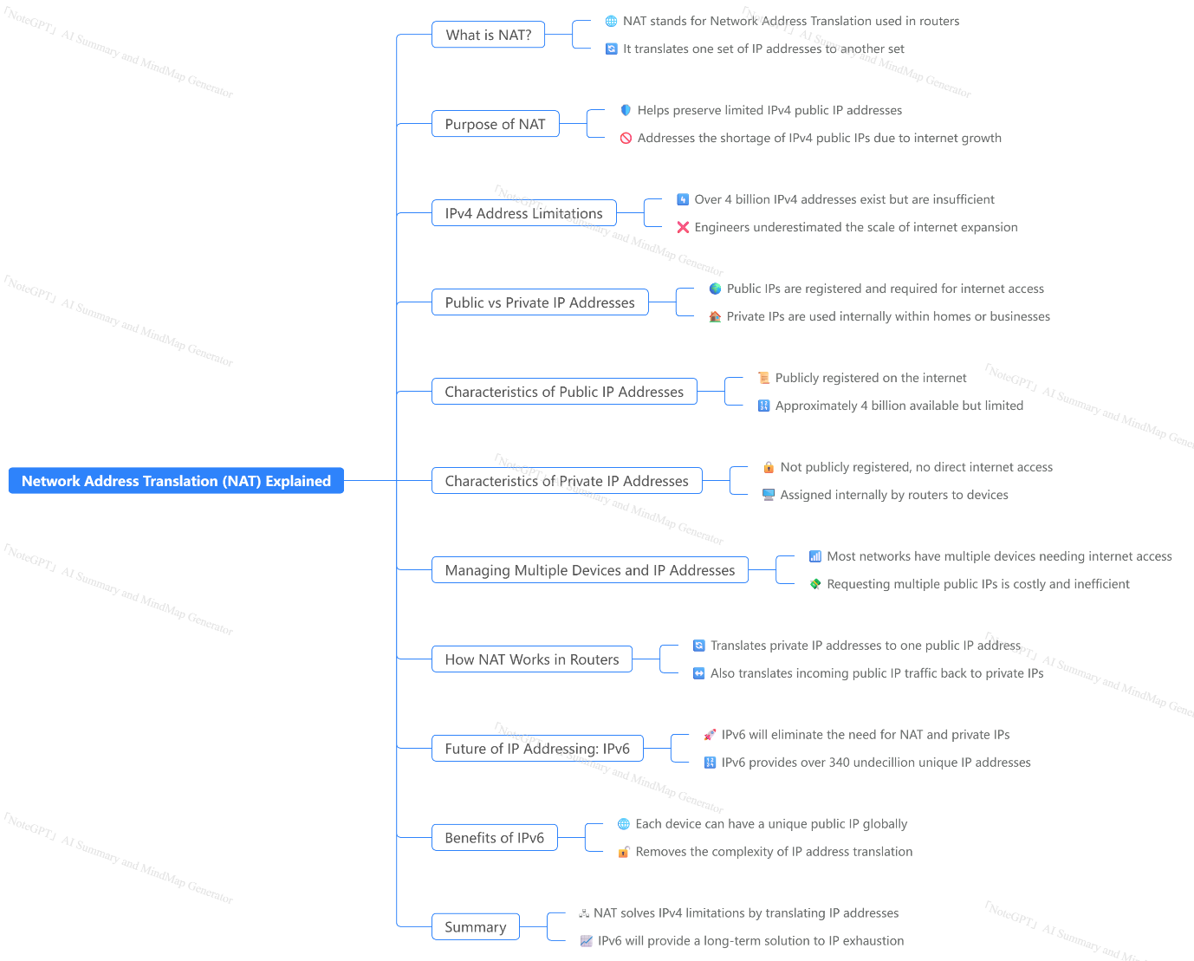

VLAN

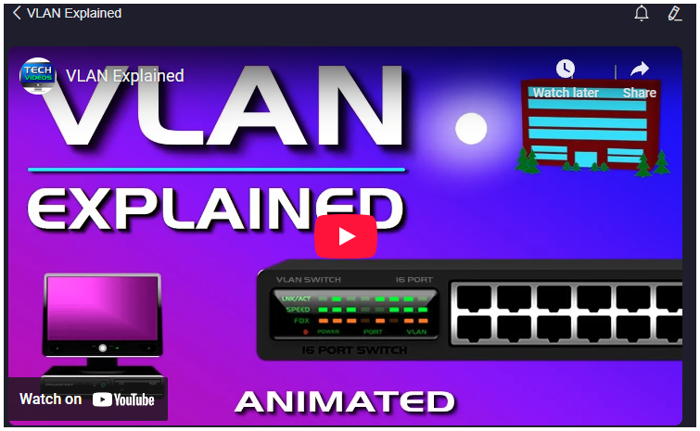
https://www.youtube.com/watch?v=jC6MJTh9fRE&ab_channel=PowerCertAnimatedVideos

### Summary
The video provides a comprehensive explanation of VLANs (Virtual Local Area Networks), emphasizing their definition, purpose, and practical application in a network environment. A VLAN is a logical grouping of network devices such as computers and servers, which allows them to communicate as if they were on the same physical network, regardless of their physical locations. The core advantage of VLANs is the improved management of network traffic, enhanced security, and simplified network administration without needing physical relocation of devices or extensive cabling changes.

The example used in the video involves a three-story office building where computers from different departments—accounting, shipping, and support—are mixed on the same floor and connected to a single switch. Without VLANs, all devices share the same broadcast domain, resulting in all departments seeing each other’s network traffic, which can lead to security concerns and network congestion. The traditional solution of physically moving computers to separate floors or deploying additional hardware is cumbersome.

Instead, VLANs allow the network administrator to logically partition the switch ports into separate virtual networks, assigning each department a dedicated VLAN. This segmentation isolates broadcast traffic within each VLAN, preventing departments from seeing each other’s traffic and reducing unnecessary broadcast traffic. By implementing VLANs, the administrator can maintain existing physical cabling and hardware while achieving traffic isolation and better traffic management.

The video further highlights that VLANs reduce broadcast traffic congestion by dividing the network into smaller broadcast domains, which is particularly beneficial as the network scales and more devices are added. Assigning switch ports to specific VLANs creates these virtual boundaries, allowing greater control over network traffic flow, security, and efficiency.

### Highlights
- 🖥️ VLANs logically group devices regardless of physical location.
- 🔒 VLANs enhance network security by isolating traffic between departments.
- 🚦 VLANs improve traffic management by reducing broadcast traffic congestion.
- 🏢 VLANs prevent the need for physical relocation or additional cabling.
- 🔌 VLANs are created by assigning switch ports to specific virtual networks.
- 📈 VLANs help manage network growth by dividing large broadcast domains into smaller ones.
- ⚙️ VLANs simplify network administration while maintaining existing infrastructure.

### Key Insights
- 🧩 **Logical Segmentation Over Physical Segmentation:** VLANs represent a shift from traditional networking, where physical location dictated network segmentation, to logical segmentation, allowing devices anywhere to be grouped virtually. This flexibility reduces infrastructure costs and complexity, especially in large organizations with dispersed devices.
- 🔐 **Security Through Traffic Isolation:** VLANs inherently provide a layer of security by isolating network traffic. Without VLANs, all devices on a LAN receive broadcast traffic from all others, which can expose sensitive data or increase vulnerability to attacks. VLANs ensure that traffic is contained within departmental groups, reducing the risk of unauthorized access or eavesdropping.
- 📉 **Reduction of Broadcast Traffic:** Broadcast traffic, if unchecked, can saturate a network and degrade performance. VLANs create smaller broadcast domains, limiting the scope of broadcast messages. This containment helps optimize network efficiency, especially as the number of connected devices increases. The video demonstrates this key benefit in an office setting with multiple departments.
- 🔄 **Ease of Network Management:** VLANs facilitate easier network reconfiguration without physical intervention. Instead of rewiring or moving devices, administrators can simply reassign switch ports to different VLANs as organizational needs change. This reduces downtime and operational costs.
- 🏢 **Practical Application in Multi-Department Environments:** The example of different departments on the same floor physically connected to one switch illustrates a common real-world scenario. VLANs solve this problem elegantly by enabling logical separation within the same physical infrastructure, which is often the case in offices, data centers, and campus networks.
- 🛠️ **VLAN Implementation via Switch Configuration:** VLANs are implemented by configuring VLAN-capable switches, assigning specific ports to individual VLANs. This process is straightforward yet powerful, allowing granular control over network traffic paths and access policies. Understanding this mechanism is crucial for network administrators.
- 📈 **Scalability and Future-Proofing:** As networks grow, broadcast traffic naturally increases, which can lead to congestion and degraded performance. VLANs provide a scalable solution by subdividing networks into manageable segments, ensuring that the network remains efficient and secure even as more devices come online.

In conclusion, VLANs are a vital tool for modern network design, offering logical segmentation, improved security, better traffic management, and ease of administration without requiring physical changes to the network layout. Their implementation is essential for organizations looking to optimize their network infrastructure while maintaining flexibility and scalability.

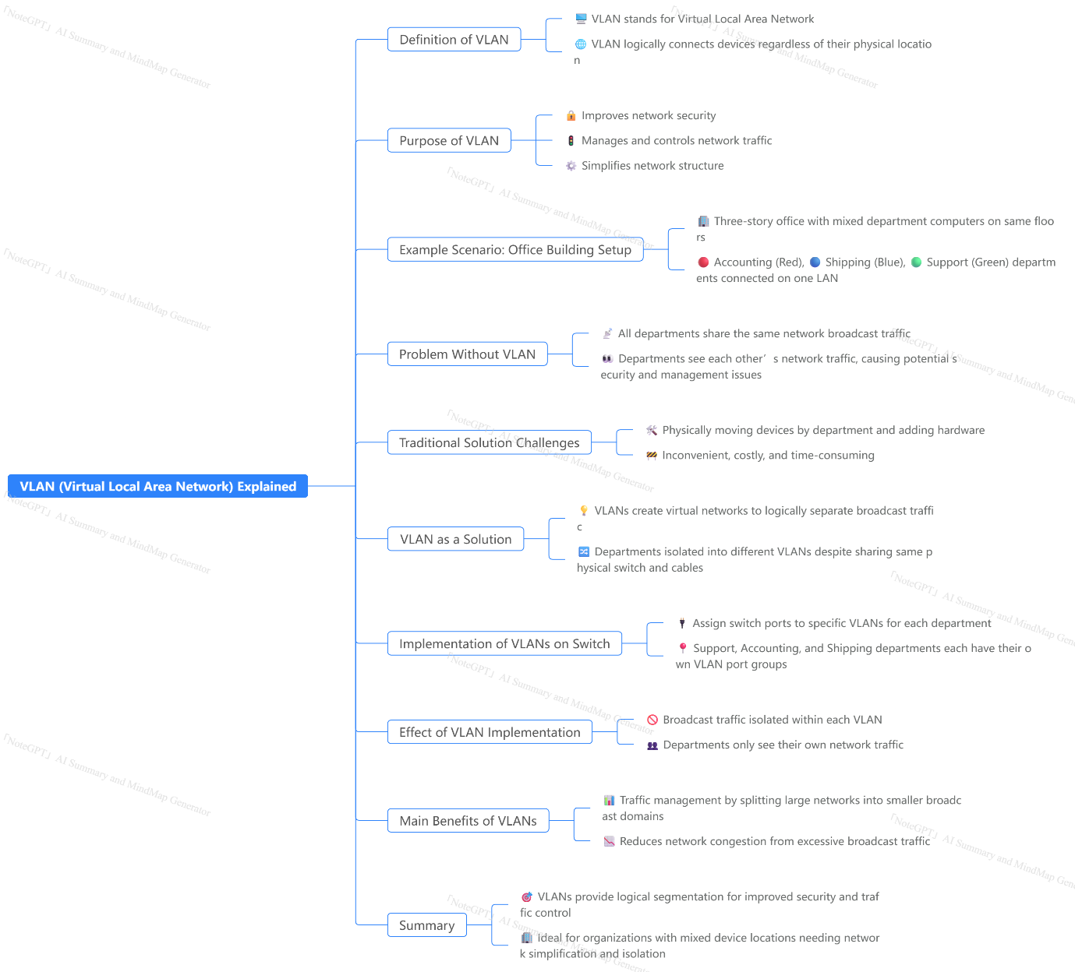

SSL CERITFICATE WORKS..?

https://youtu.be/0yw-z6f7Mb4?si=IkXLzUN8HBcTRKpv

### Summary
This video provides a detailed explanation of how SSL (Secure Sockets Layer) certificates work to secure communication between a client's browser and a web server. It is aimed at intermediate to advanced web developers who want to understand the internal mechanics of SSL certificates beyond their superficial use for securing websites. The video starts by explaining the basic problem of unsecured communication on the internet, highlighting the risk of man-in-the-middle (MITM) attacks where attackers can intercept and read data transmitted between clients and servers.

The presenter then introduces the concept of encryption and the types of encryption: symmetric and asymmetric. Symmetric encryption uses a single key for both encrypting and decrypting data, which poses a challenge of securely exchanging the key between client and server without it being intercepted. To solve this, asymmetric encryption uses a pair of keys: a public key (available openly) to encrypt data and a private key (kept secret) to decrypt it.

The video explains how SSL certificates use this asymmetric encryption to securely exchange a symmetric key between client and server. The server provides its public key to the client, which the client uses to encrypt a symmetric key it generates. The encrypted symmetric key is sent back to the server, which decrypts it with its private key. Now, both client and server share the same symmetric key to encrypt and decrypt the actual data transferred, ensuring the communication remains confidential.

However, the video also addresses the vulnerability of MITM attacks where an attacker could impersonate the server and provide their own public key to the client. To prevent this, SSL certificates are introduced as a trusted mechanism issued by certificate authorities (CAs) like Let’s Encrypt. The certificate contains the server’s public key along with a digital signature from the CA that verifies the authenticity of the key. The client verifies the certificate by checking the CA’s signature, ensuring it is communicating with the genuine server and not an attacker.

Finally, the presenter describes the process of obtaining an SSL certificate, the role of the CA, and how the browser verifies the certificate before establishing a secure connection. The video also mentions the possibility of creating self-signed certificates for local development, although these are not trusted by browsers and produce warnings.

Overall, the video provides a comprehensive overview of the cryptographic principles behind SSL certificates and their critical role in securing internet communications.

### Highlights
- 🔐 Explanation of how SSL certificates secure data transmission between client and server.
- 🕵️‍♂️ Identification of man-in-the-middle attacks and their risks in unsecured communication.
- 🔑 Distinction between symmetric and asymmetric encryption and their roles in SSL.
- 🛡️ How asymmetric encryption enables secure key exchange without risking interception.
- 📜 Role of certificate authorities (CAs) in authenticating public keys via SSL certificates.
- ✅ Step-by-step process of verifying SSL certificates in browsers.
- 🖥️ Mention of self-signed certificates for local testing and their limitations.

### Key Insights
- 🔐 **The necessity of encryption for secure communication:** The video emphasizes that without encryption, data sent over the internet can be easily intercepted by attackers. This highlights encryption as the foundational technology underpinning internet security, protecting sensitive information like passwords, credit card details, and personal data.

- 🔑 **Symmetric encryption is efficient but insecure for key exchange:** Symmetric encryption uses a single key to encrypt and decrypt data, but sharing this key between client and server without interception is a major challenge. This insight shows why symmetric encryption alone is insufficient for secure communications over open networks.

- 🗝️ **Asymmetric encryption solves the key exchange problem:** By using a pair of keys (public and private), asymmetric encryption allows the client to securely send the symmetric key encrypted with the server’s public key. Only the server’s private key can decrypt this, preventing attackers from accessing the symmetric key even if they intercept the transmission. This is a critical breakthrough in cryptographic communication.

- 🕵️‍♂️ **Man-in-the-middle attacks exploit trust vulnerabilities:** Attackers can intercept communication and impersonate the server by providing their own public key to the client, effectively breaking the security model. This highlights the importance of verifying the identity of the server to prevent such attacks.

- 📜 **SSL certificates and certificate authorities restore trust:** SSL certificates are digital documents issued by trusted authorities that bind a server’s public key to its identity (domain). The CA’s digital signature on the certificate allows clients to verify that the public key truly belongs to the intended server, preventing attackers from impersonating it. This system of trust is essential for secure internet communication.

- ✅ **Browser verification of SSL certificates is a critical security step:** Browsers check the certificate’s signature against known certificate authorities to validate the server’s identity. This process ensures that encrypted communication is established with the legitimate server, safeguarding users from phishing or MITM attacks.

- 🖥️ **Self-signed certificates serve development but lack public trust:** For local testing, developers can create self-signed certificates, which function technically the same but are not vouched for by a CA, causing browser warnings. This distinction clarifies the difference between trusted and untrusted certificates in real-world usage.

### Extended Explanation
The video begins by setting the context of internet communication involving two parties: the client (user’s browser) and the server (hosting the website or application). When communication is unencrypted, any entity positioned on the network path — a man-in-the-middle attacker — can easily intercept, read, and manipulate the data exchanged. This fundamental problem necessitates encryption.

The simplest form of encryption is symmetric encryption, where one key is used for both encrypting and decrypting data. The challenge here is securely sharing this key between client and server. If the key is sent openly, attackers can capture it and decrypt all future communication. This vulnerability defeats the purpose of encryption.

Asymmetric encryption addresses this by introducing two keys: a public key and a private key. The public key can be freely shared, while the private key remains secret with the server. The client encrypts data with the server’s public key, ensuring that only the server can decrypt it with its private key. This mechanism enables secure sharing of symmetric keys, which then encrypt the actual data transmissions efficiently.

Despite this, attackers may still attempt MITM attacks by masquerading as the server and providing their own public key to the client. To counter this, SSL certificates come into play. These certificates are issued by certificate authorities (CAs), trusted third parties that verify a server's identity. When a server requests a certificate, it provides its public key to the CA, which verifies the server’s domain ownership and creates a signed certificate binding the public key to the server’s identity.

When a client connects to the server, it receives both the server’s public key and its SSL certificate. The client verifies the certificate’s authenticity by checking the CA’s digital signature against a trusted list of CAs. If verified, the client can trust that the public key belongs to the intended server, not an attacker. The client then encrypts the symmetric key with the server’s public key and sends it securely. From this point, both parties use the symmetric key for fast, secure communication.

The video also covers the practical aspect of obtaining SSL certificates, mentioning popular providers like Let’s Encrypt that issue free certificates. It explains the cryptographic signing process involving the server’s public key and the CA’s keys to create the certificate. The video concludes by clarifying the difference between CA-signed certificates and self-signed certificates, the latter useful for local development but not trusted publicly.

This comprehensive explanation demystifies the workings of SSL certificates, emphasizing their role in securing billions of daily internet communications by ensuring confidentiality, integrity, and authenticity.

### Conclusion
Understanding SSL certificates requires grasping fundamental cryptographic concepts like symmetric and asymmetric encryption, the key exchange problem, and the trust model established by certificate authorities. This video successfully breaks down these technical concepts into understandable steps, illustrating how SSL certificates enable secure, trusted communication over the inherently insecure internet. For any web developer or security enthusiast, this knowledge is crucial for building and maintaining secure web applications.

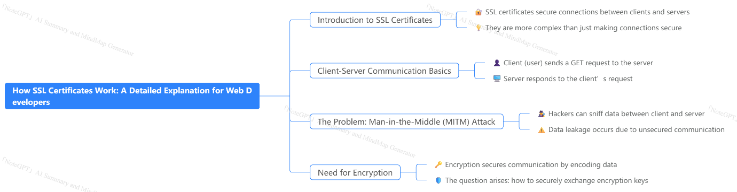

SSL (Secure Socket Layer)
and
TLS (Transport Layer Security

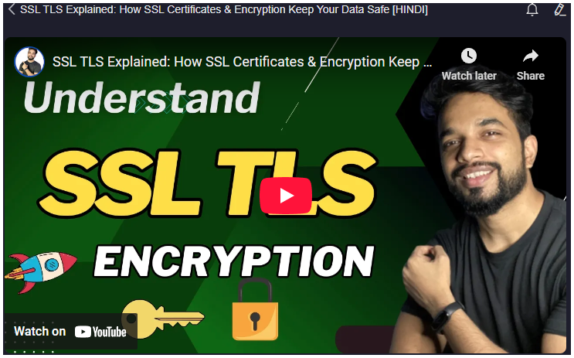
https://youtu.be/I43NnHTeACk?si=_kO-pi08LfVP4K7t
### Summary
The video provides a comprehensive explanation of SSL (Secure Socket Layer) and TLS (Transport Layer Security) technologies, which are cryptographic protocols used to secure sensitive data transmission over the internet. It starts by emphasizing the importance of encrypting sensitive data such as passwords during activities like online banking to prevent hackers from intercepting and misusing the data.

TLS is explained as the successor to SSL, and though SSL is still commonly mentioned, in practice, TLS is the protocol in use today. The video demonstrates how browsers indicate secure connections using HTTPS and lock icons, ensuring encrypted communication between the client (user’s browser) and server (website).

The core principles SSL/TLS maintain are confidentiality, integrity, and authenticity. These are achieved through three main methods: encryption to keep data confidential, hashing to ensure data integrity, and certificates for authentication. The video uses a relatable example of securely transferring an exam question paper to explain these principles.

Encryption is detailed with two types: symmetric encryption (using the same key for encryption and decryption) and asymmetric encryption (using a public-private key pair). Symmetric encryption is faster and efficient for large data but has challenges in key distribution. Asymmetric encryption is more secure but computationally intensive and better suited for small critical data. The video introduces hybrid encryption, which combines both methods by using asymmetric encryption to exchange symmetric keys, then symmetric encryption for bulk data transfer, balancing security and efficiency.

Hashing is covered as a technique to verify data integrity by converting data into a fixed-size string (hash) that acts like a digital fingerprint. If the data changes, the hash changes, indicating tampering. To prevent forgery of hashes, the video explains Message Authentication Codes (MAC), which combine the message with a secret key before hashing, making it difficult for attackers to alter data without detection.

Certificates and Certificate Authorities (CAs) are explained as the tools for verifying the authenticity of websites. Website owners obtain digital certificates from trusted CAs, which include the public key and identity details. Browsers use these certificates to validate that the website is genuine and secure before establishing encrypted communication.

Finally, the video walks through the SSL/TLS handshake process, describing how the client and server negotiate supported protocols and algorithms, exchange certificates, validate them, and establish a secure session key for encrypted communication.

The video concludes with a summary of the step-by-step SSL/TLS workflow and invites viewers to comment if they want a practical demonstration video.

### Highlights
- 🔐 TLS is the modern, secure successor to SSL, commonly used for encrypting internet communication.
- 🔑 Encryption ensures confidentiality; hashing guarantees data integrity, and certificates provide authentication.
- 🔄 Hybrid encryption combines symmetric and asymmetric methods for efficient and secure data transfer.
- 🧩 Hashing converts data into a fixed-size string to detect any tampering during transmission.
- 📜 Digital certificates issued by trusted Certificate Authorities verify website authenticity.
- 🔄 SSL/TLS handshake enables client-server agreement on protocols, certificate exchange, and secure session key creation.
- 🛡️ Secure connections on browsers are indicated by HTTPS and lock icons confirming encrypted communication.

### Key Insights
- 🔐 **TLS as the Standard for Secure Communication:** TLS has replaced SSL due to advances in security protocols, but the SSL term remains popular colloquially. Understanding this helps avoid confusion and aligns with current best practices for secure communications. TLS ensures data privacy and security in online banking, e-commerce, and other sensitive applications, making it foundational to internet security.

- 🔑 **Three Pillars of Data Security:** Confidentiality, integrity, and authenticity are the core principles of secure communication. Confidentiality protects data from unauthorized access; integrity ensures data is not altered during transmission, and authenticity verifies identities of communicating parties. These principles prevent data breaches, tampering, and impersonation attacks, which are critical for trust in digital interactions.

- 🔄 **Hybrid Encryption Balances Security and Efficiency:** By combining asymmetric encryption (for secure key exchange) and symmetric encryption (for fast data encryption), hybrid encryption overcomes the limitations of both methods. This approach is widely adopted in SSL/TLS protocols and modern cryptographic systems, enabling secure and efficient handling of large volumes of data.

- 🧩 **Hashing and Message Authentication Codes (MAC) for Integrity:** Hash functions produce a unique fixed-length output for any input data, allowing receivers to verify the data’s integrity by comparing hash values. MAC incorporates a secret key into hashing, providing protection against attackers who might try to alter both the message and its hash. This layered approach strengthens data integrity verification.

- 📜 **Role of Digital Certificates and Certificate Authorities:** Certificates serve as digital IDs for websites, proving their authenticity to users and browsers. Trusted third-party Certificate Authorities issue these certificates after verifying the organization’s identity. This system builds trust on the internet and prevents man-in-the-middle attacks by ensuring users connect to legitimate websites.

- 🔄 **SSL/TLS Handshake Process Ensures Secure Session Establishment:** The multi-step handshake negotiates the protocol version and cipher suites, exchanges certificates, and securely establishes a shared session key. This process is essential because it sets up a secure channel before any sensitive data is transmitted, preventing eavesdropping and impersonation.

- 🛡️ **Browser Indicators Reinforce User Trust:** Visual cues like the HTTPS prefix and lock icon in browsers inform users that their connection is secure. These indicators are the visible outcome of SSL/TLS processes and play a crucial role in user awareness and confidence, encouraging safe online behavior.

The video effectively bridges technical cryptographic concepts with real-world examples, helping viewers grasp how SSL/TLS protects online interactions and why these protocols are indispensable in today’s digital world.
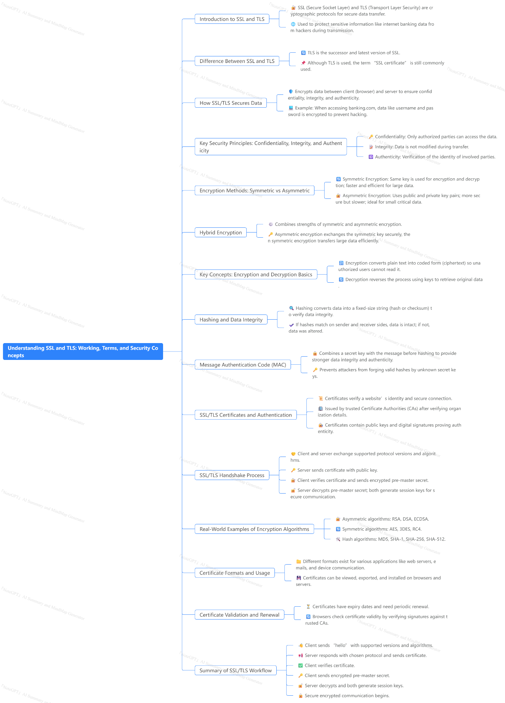

SSL (SECURE SOCKETS LAYER) HANDSHAKE PROTOCOL

https://youtu.be/Nh5jdNxPL7g?si=zp3wd_yhfSOAjTnh

### Summary
The video provides an in-depth explanation of the SSL (Secure Sockets Layer) handshake protocol, which is a critical backbone for securing communications between two entities, typically a client and a server. The handshake protocol’s primary purpose is to establish a secure communication channel and authenticate both parties before any data transfer happens. The explanation is divided into the four phases of the handshake process, detailing the messages exchanged and their significance.

In the first phase, the client initiates communication by sending a "Client Hello" message, which includes important parameters such as cryptographic algorithms (cipher suites) and compression methods supported by the client. The server responds with a "Server Hello" message, selecting the algorithms and methods that will be used during the session, thus establishing a logical connection.

The second phase focuses on authentication. The server authenticates itself to the client by sending its digital certificate. Subsequently, the server requests the client’s certificate to authenticate the client. The server also sends its public key to the client to aid in secure key exchange.

In the third phase, the client responds by sending its certificate, thereby authenticating itself to the server. This mutual authentication ensures both entities are verified, establishing trust.

The final phase involves the exchange of cipher specifications between the client and the server, signaling the completion of the handshake process. Both sides confirm the use of agreed-upon cryptographic parameters, finalizing the secure communication channel.

Throughout the handshake, the video emphasizes three critical aspects: authentication, integrity, and confidentiality, which are essential for secure data transmission. The SSL handshake protocol not only authenticates the communicating parties but also ensures data integrity and confidentiality through encryption.

### Highlights
- 🔐 SSL handshake protocol is the backbone of secure communication between client and server.
- 🤝 Mutual authentication is achieved through exchange of digital certificates during the handshake.
- ⚙️ Four distinct phases govern the handshake process with specific messages and tasks.
- 🛡️ Cryptographic algorithms and compression methods are negotiated and finalized early in the handshake.
- 🔑 The exchange of public keys facilitates secure key establishment for encrypted data transfer.
- 📜 Authentication ensures both client and server verify each other's identities.
- 🔒 The handshake protocol guarantees integrity and confidentiality for the transmitted data.

### Key Insights
- 🔐 **SSL Handshake as a Security Foundation:** The handshake protocol is fundamental in establishing a trusted and secure connection. By authenticating both client and server before any data exchange, it prevents unauthorized access and potential man-in-the-middle attacks. This initial trust setup is crucial for secure internet communications, such as HTTPS.

- 🤝 **Mutual Authentication Strengthens Trust:** Unlike simpler protocols that only authenticate the server, the SSL handshake enables two-way authentication. This means the client also proves its identity to the server, which is especially important in sensitive environments like banking or enterprise networks where both parties must trust each other.

- ⚙️ **Phased Approach Ensures Structured Communication:** Dividing the handshake into four phases—client hello, server hello, authentication, and key exchange—provides a clear, step-by-step protocol ensuring no phase is skipped. This structured approach avoids miscommunication and guarantees that all necessary parameters are agreed upon before data transmission.

- 🛡️ **Algorithm Negotiation Enhances Flexibility and Security:** By allowing the client to send a list of supported cipher suites and compression methods, and the server to select from them, SSL accommodates a variety of cryptographic standards. This flexibility ensures compatibility across different systems while allowing the use of the most secure and efficient algorithms available.

- 🔑 **Public Key Exchange for Confidentiality:** The exchange of public keys during the handshake allows both parties to generate a shared secret key securely. This key is then used to encrypt the data transfer, ensuring confidentiality and preventing eavesdropping. This mechanism is the cornerstone of secure communication.

- 📜 **Certificate-Based Authentication Promotes Identity Verification:** Using digital certificates issued by trusted certificate authorities (CAs) ensures that entities are who they claim to be. This prevents impersonation attacks and boosts user confidence in online transactions.

- 🔒 **Ensuring Integrity and Confidentiality:** Beyond authentication, the handshake protocol sets up mechanisms to protect data integrity and confidentiality. Integrity ensures data is not tampered with in transit, and confidentiality ensures data remains private. These goals are achieved through cryptographic algorithms agreed upon during the handshake, making SSL a comprehensive security solution.

This video effectively demystifies the complex SSL handshake protocol, highlighting its significance in secure digital communications and the technical steps involved in establishing a trusted connection.
